Installation Guide

1. Setup the lab and launch a windows instance.
2. Inside the instance install JDK, Maven, Git
3. JDK installation process

Navigate to JDK installation page (<https://www.oracle.com/java/technologies/javase/jdk11-archive-downloads.html>)

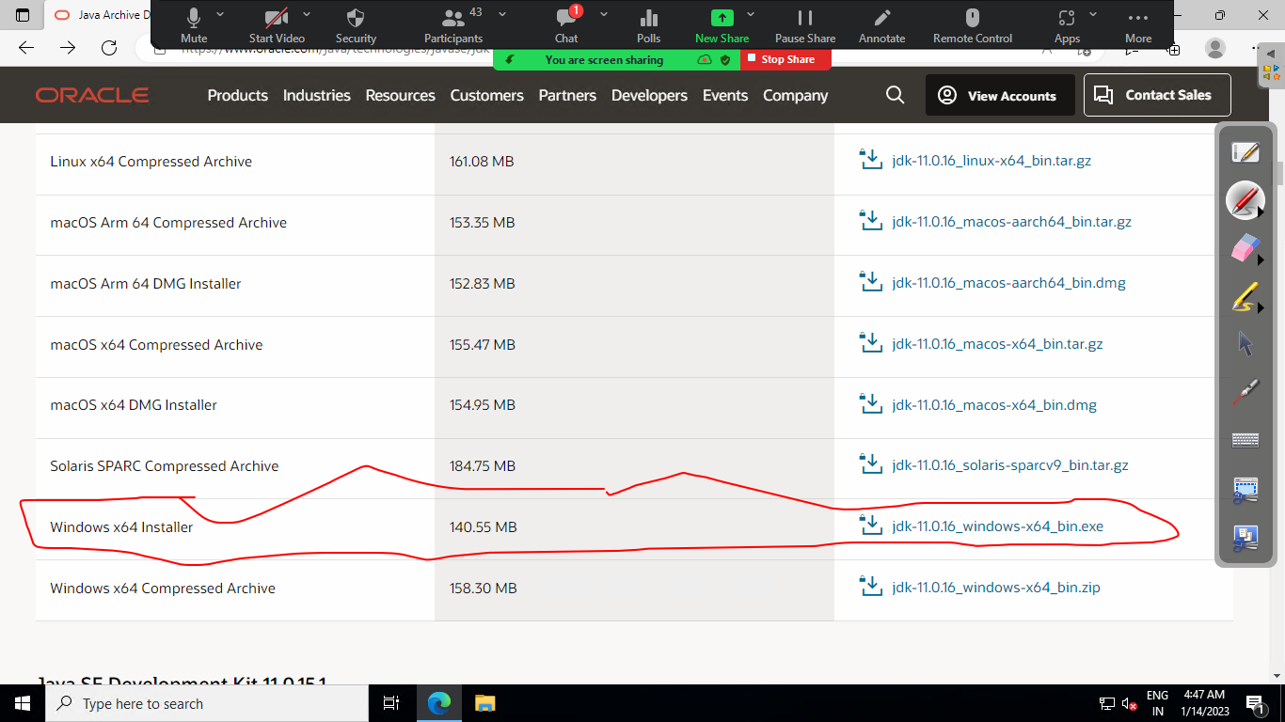

Install JDK and set the environment variable

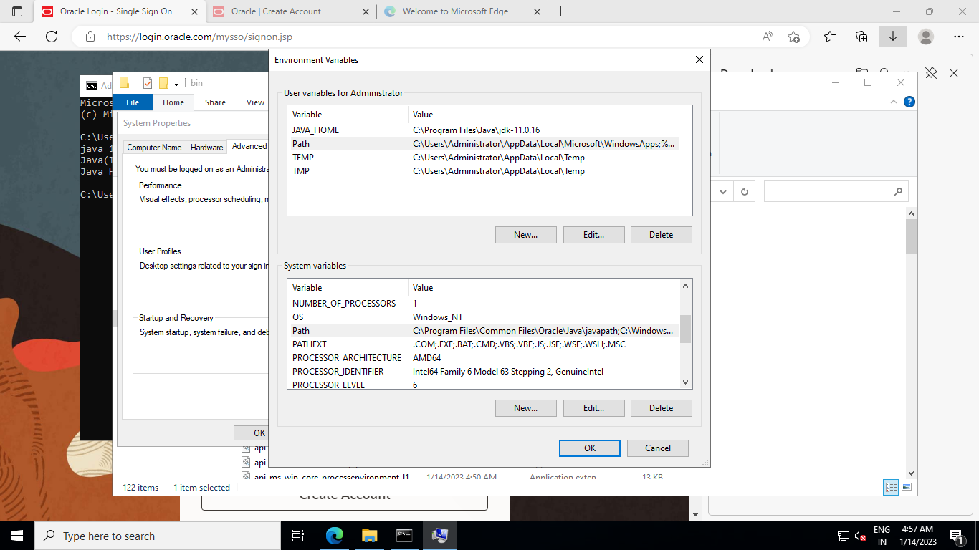

Maven Installation:

Navigate to the link and Download Manven package

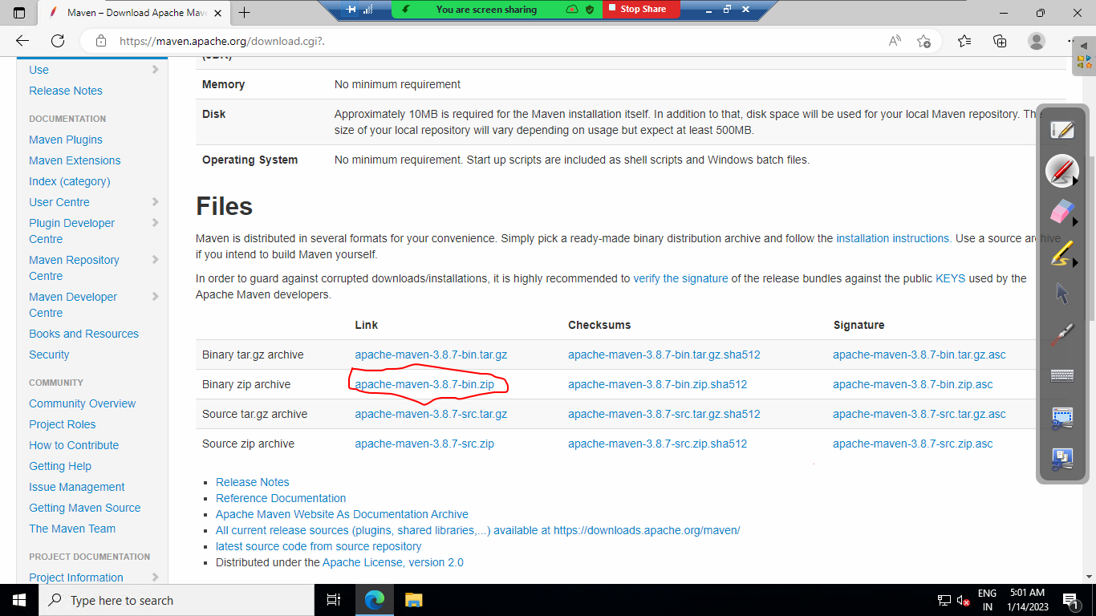

After download unzip the file and copy the maven folder inside c disk

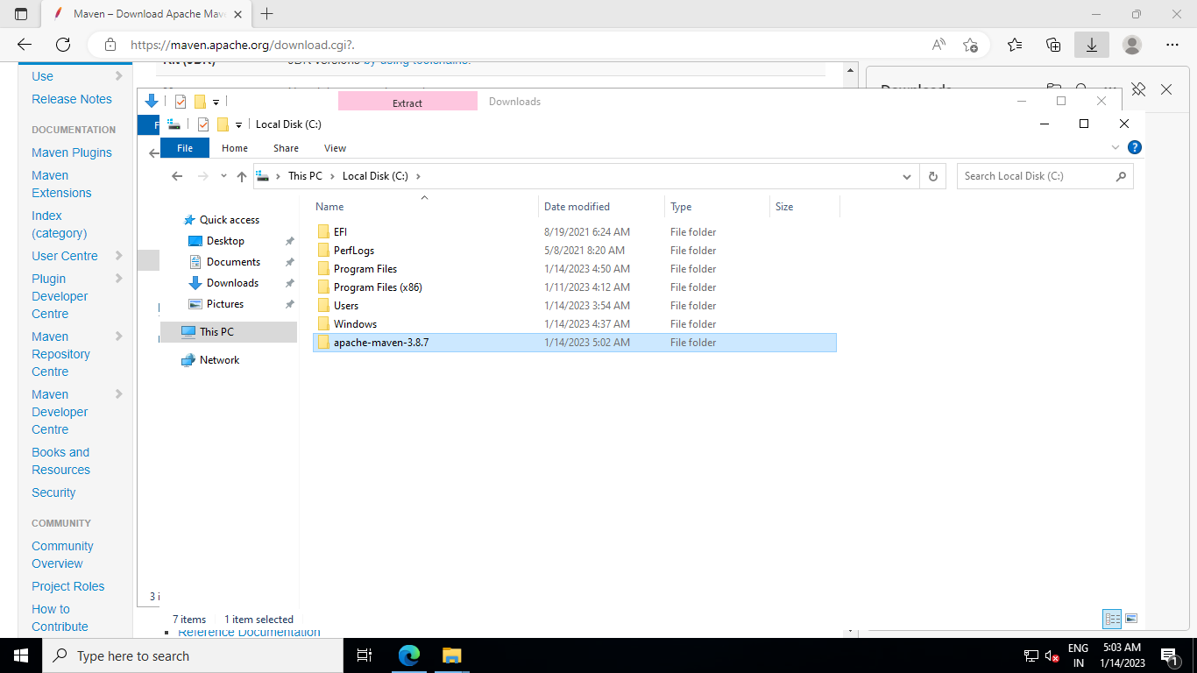

Setup environment variable for maven.

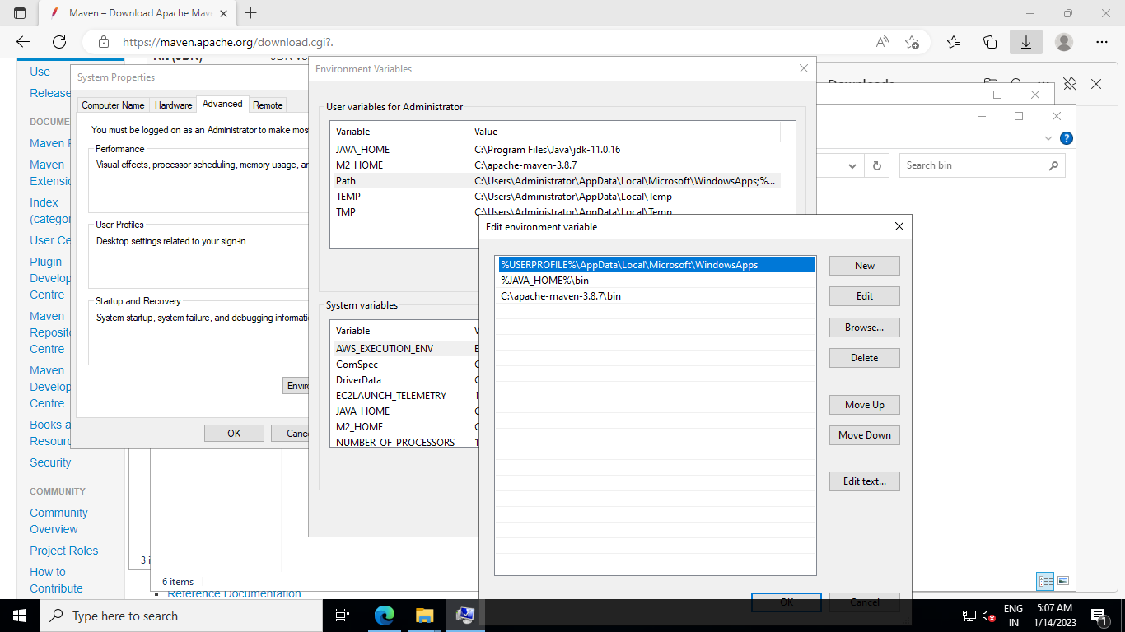

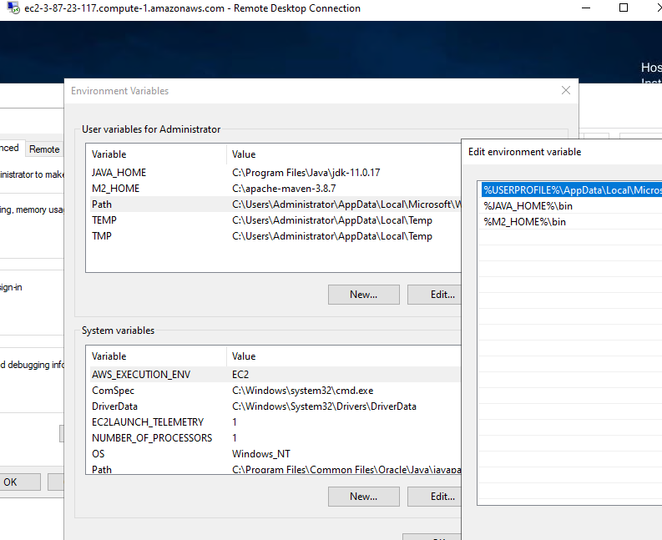

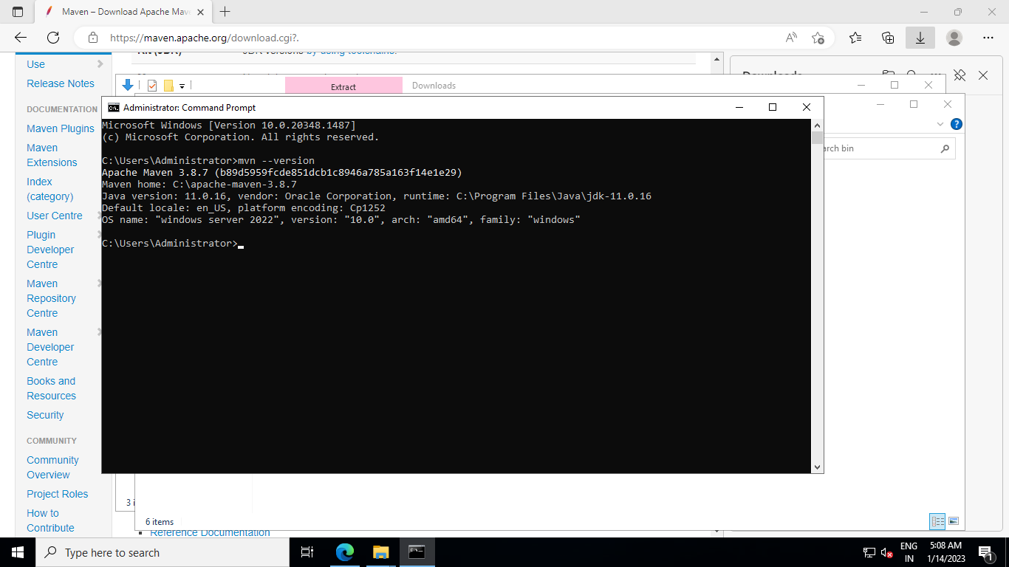

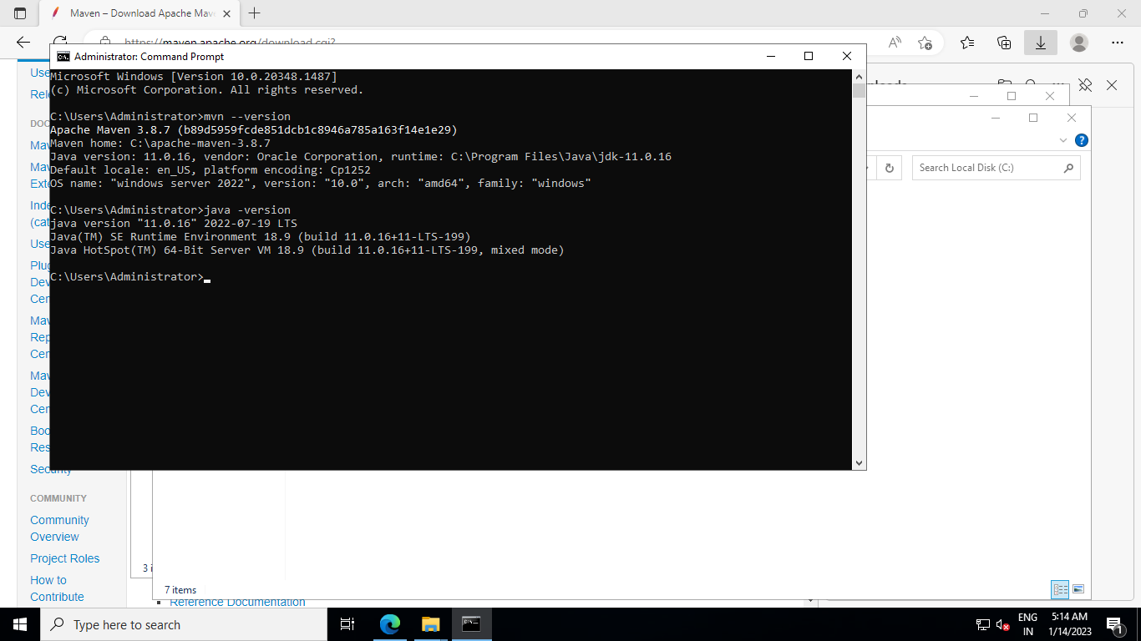

Download Jenkis (<https://www.jenkins.io/download/>)

Install Jenkins and Open the NSG inbound port tcp 8080

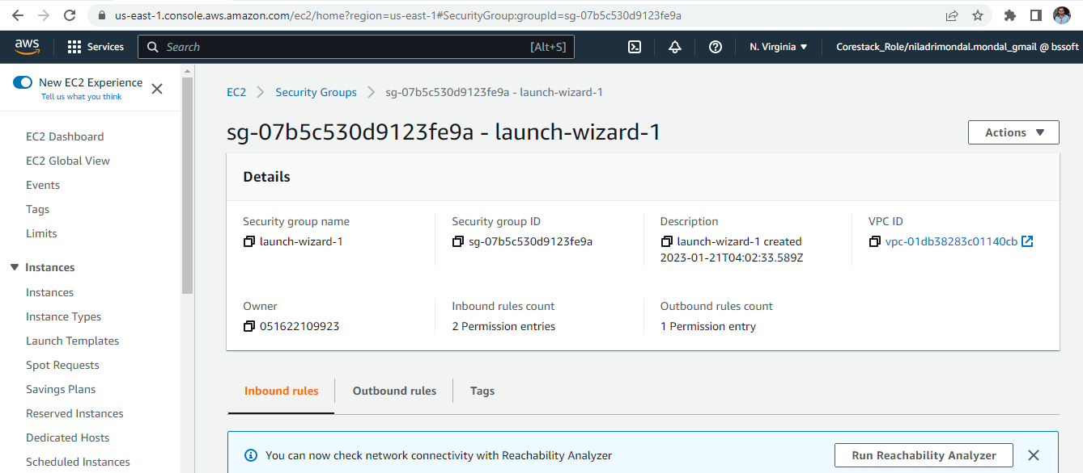

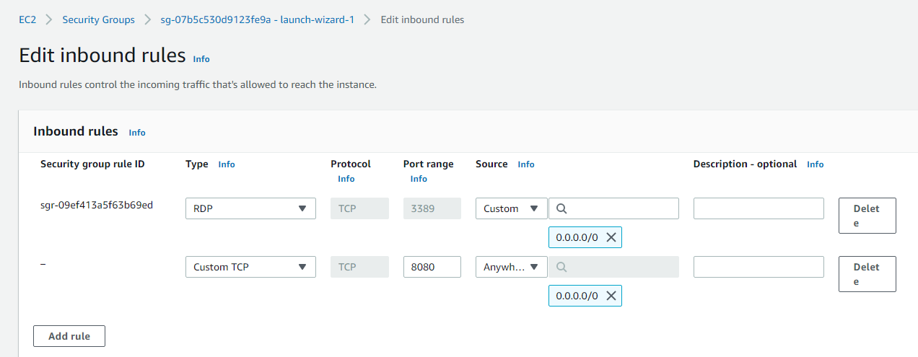

After installation navigate to Jenkins url: localhost:8080 or <server public ip>:8080

First time it will ask for the initial password and you can get the same by navigating the path mentioned.

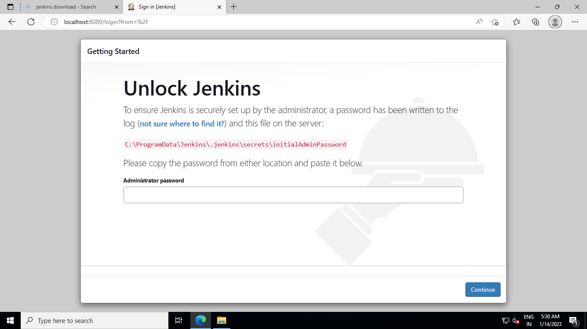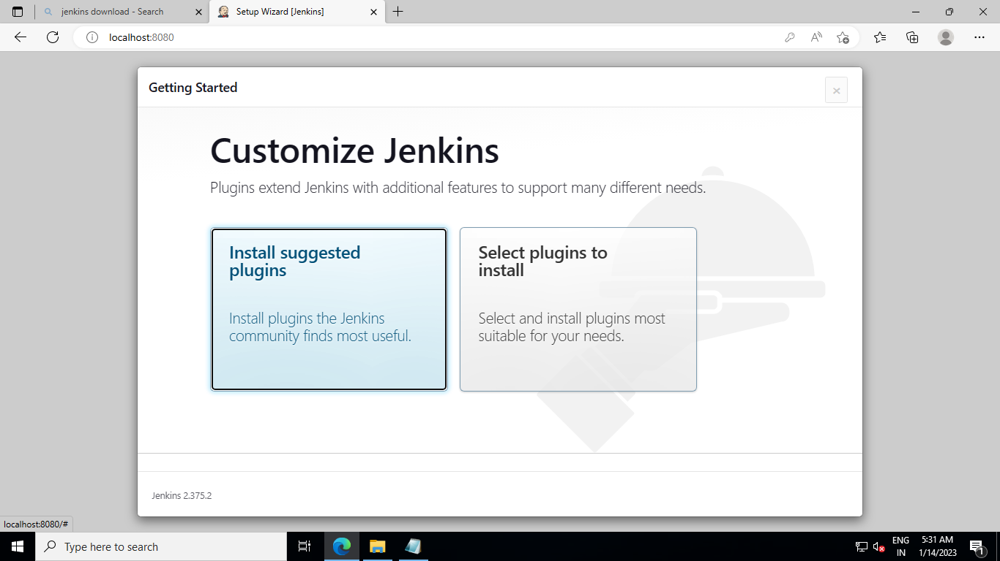

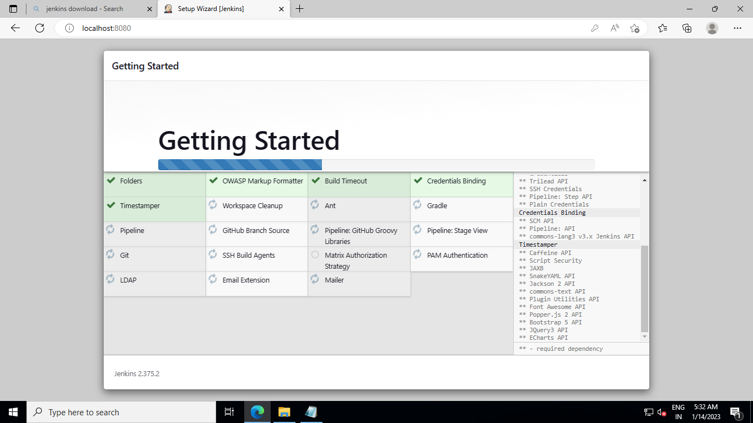

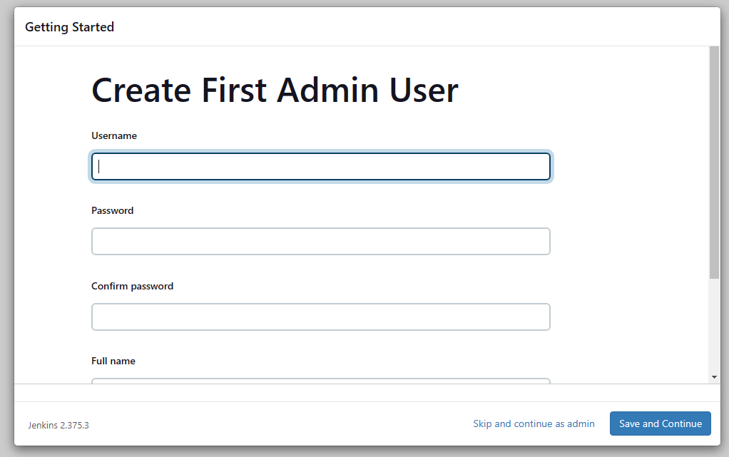

We have navigated to a page where you need to setup your admin account

Username: admin

Password : <password>

Full name: Niladri Mondal

Email id: [niladrimondal.mondal@gmail.com](mailto:niladrimondal.mondal@gmail.com)

#note: if you are not able to access the Jenkins url from your local browser. <publicip>:8080 means the server is blocking the same. To make it work you need to disable firewall of the server where Jenkins has installed.

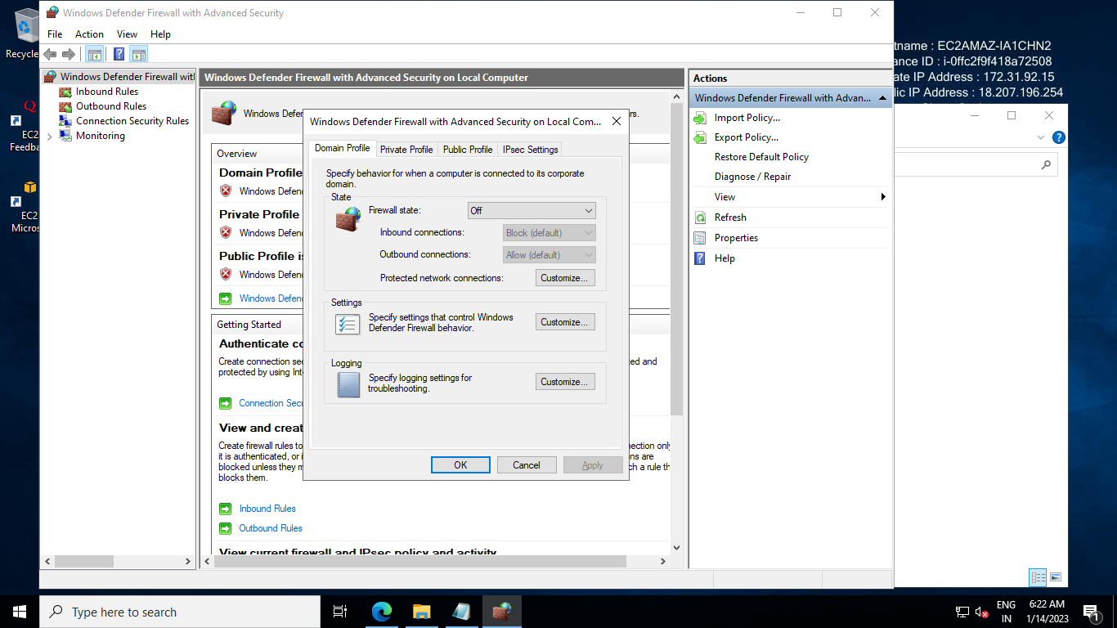

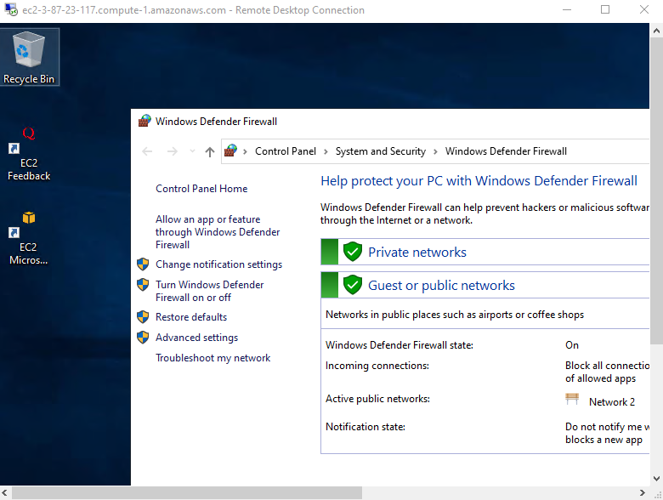

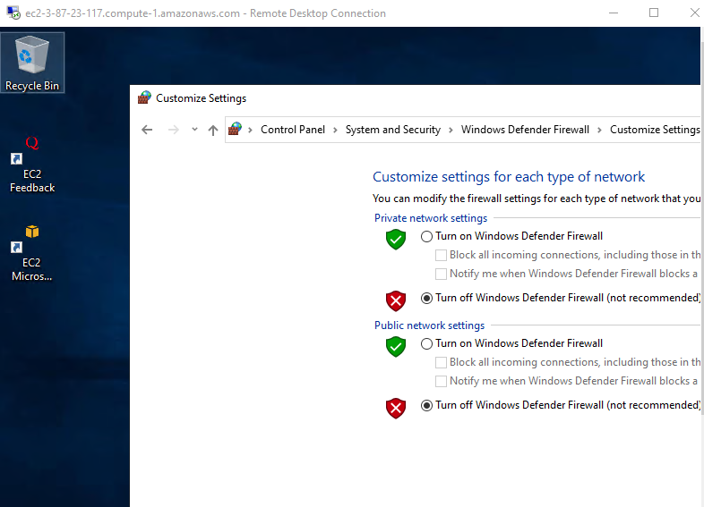

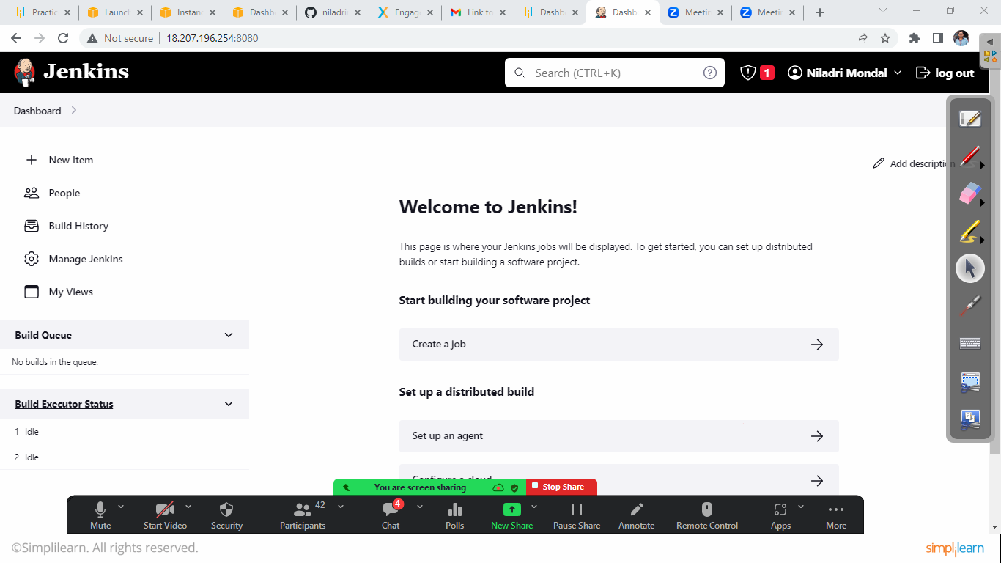

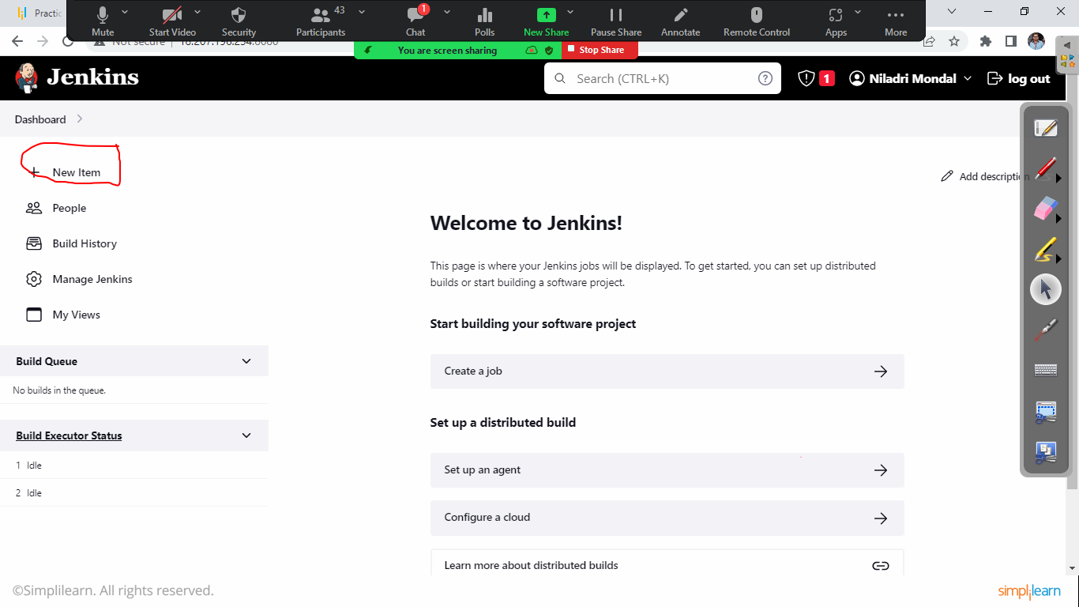

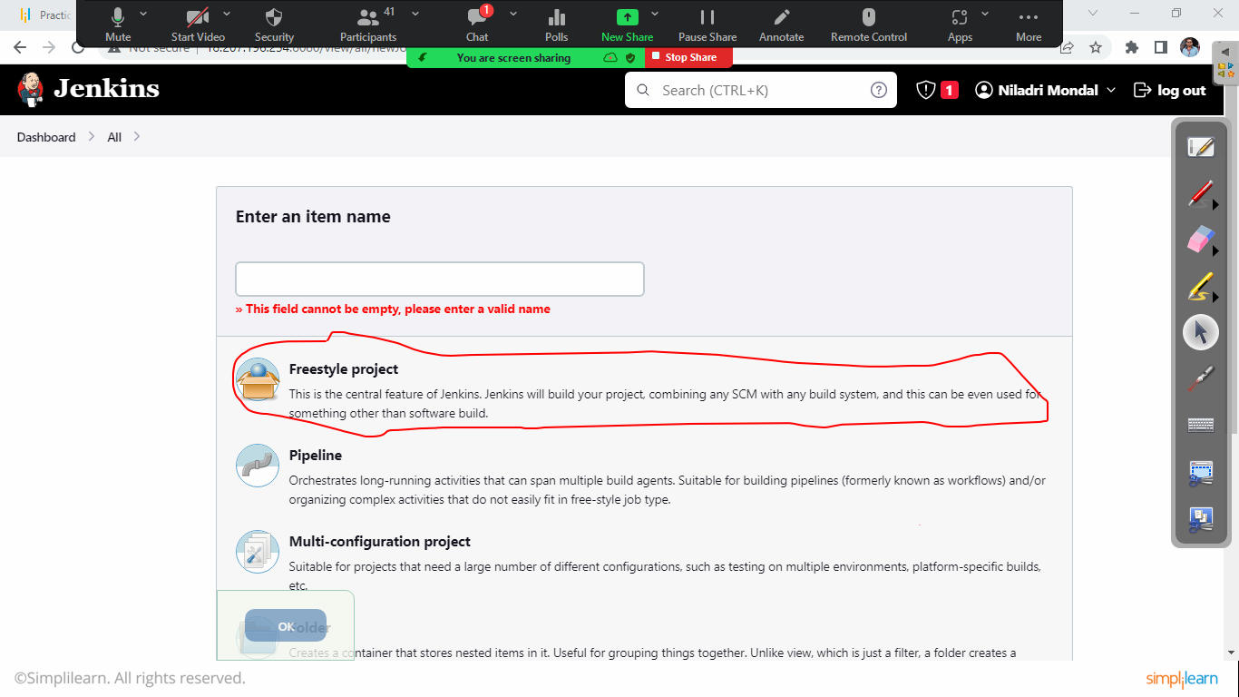

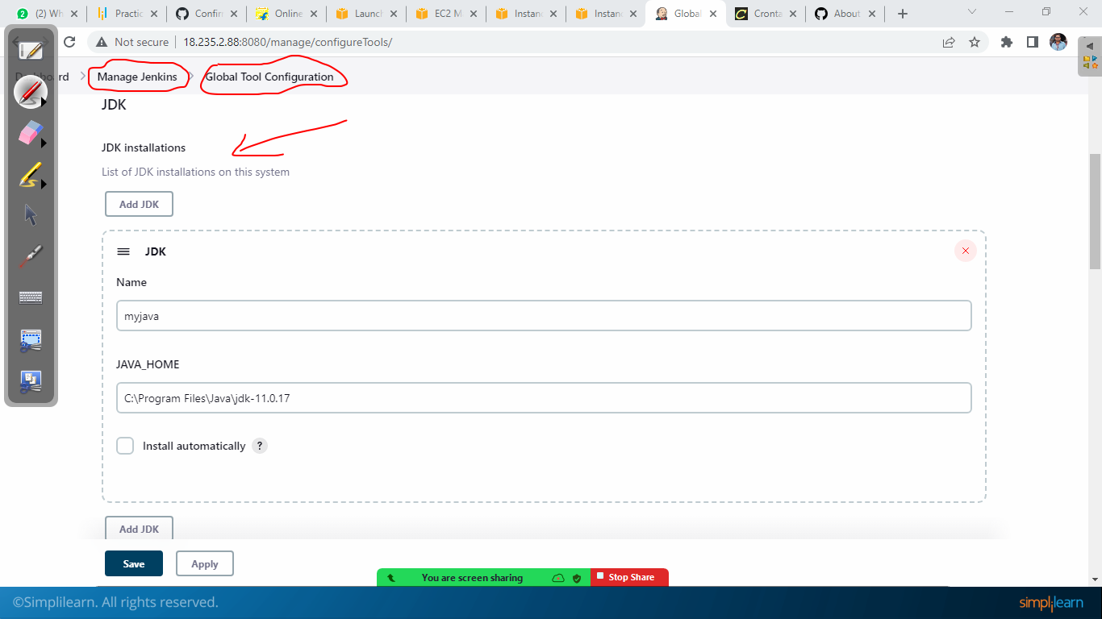

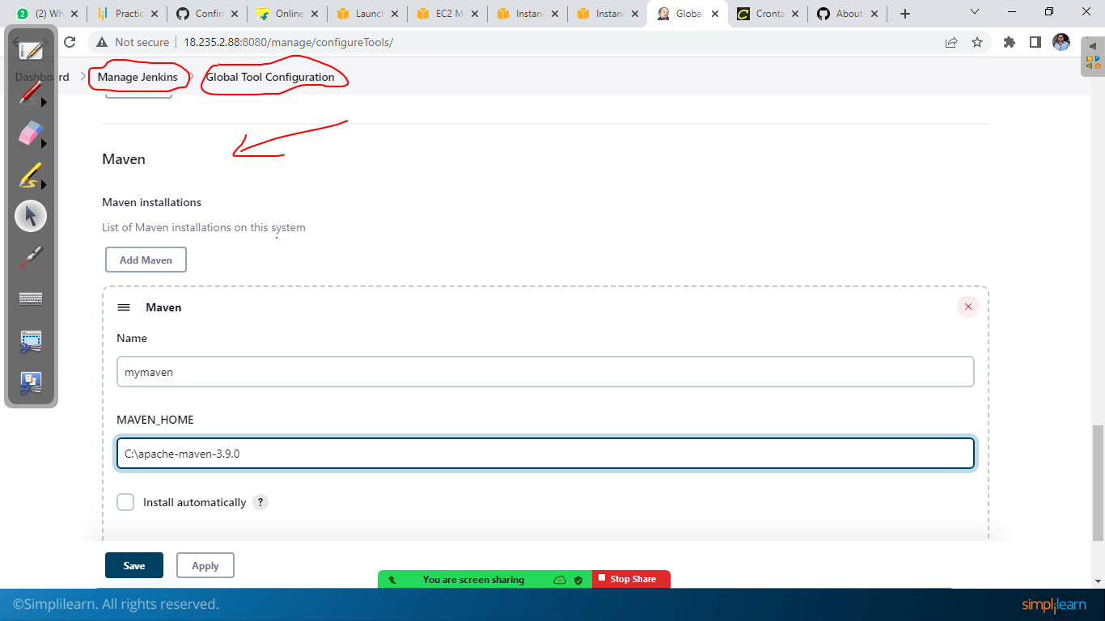

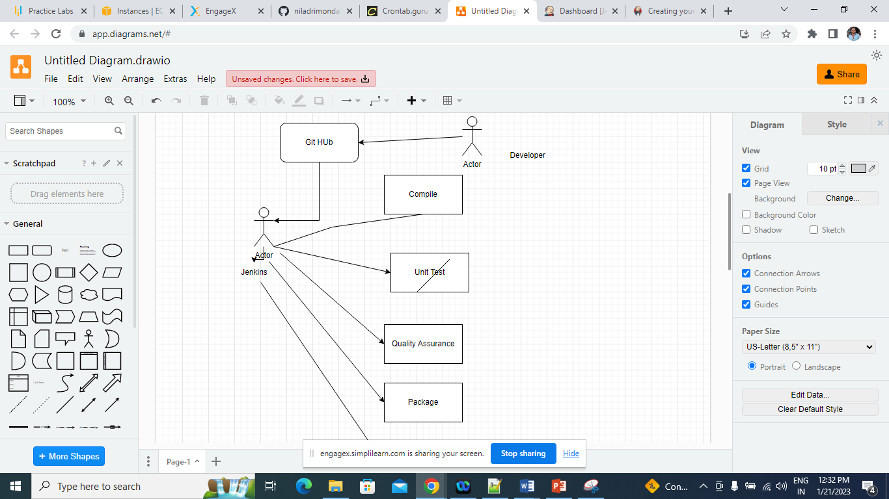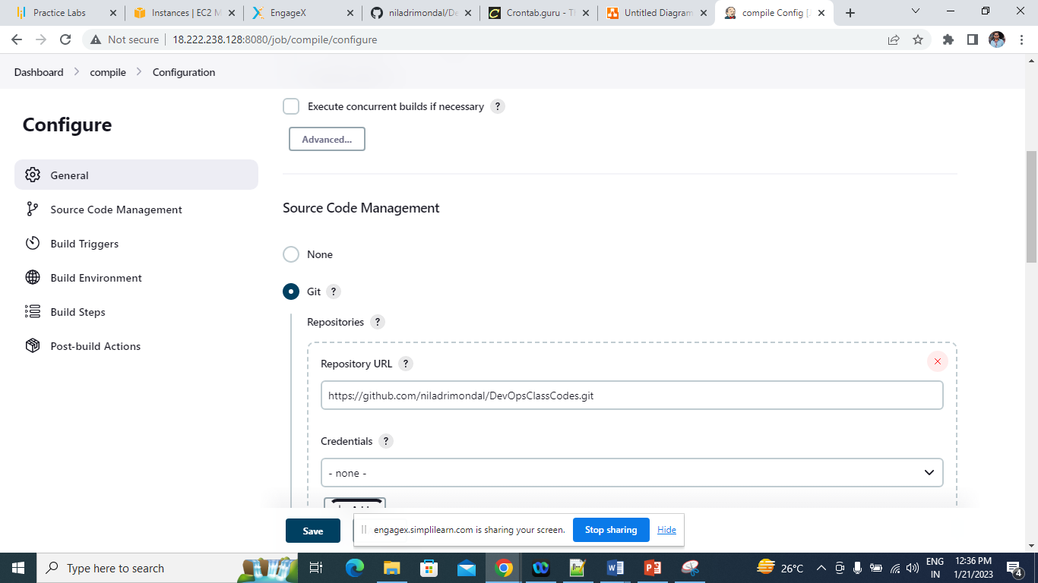

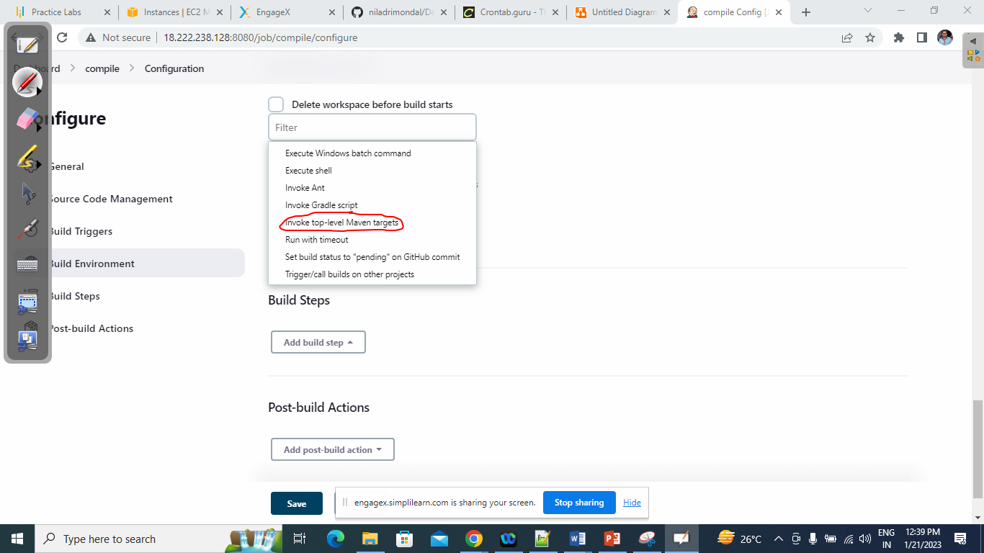



I am going to compile the source code using maven compile commmand, I have already congigured global tool configuration for my maven

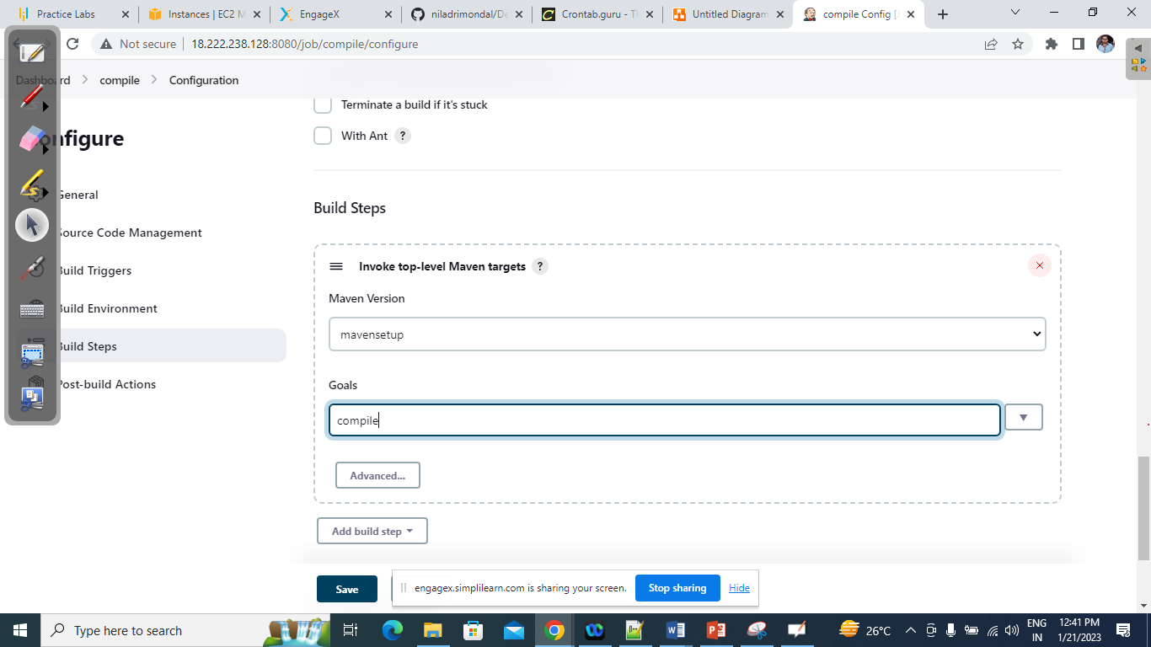

Testing Phase:

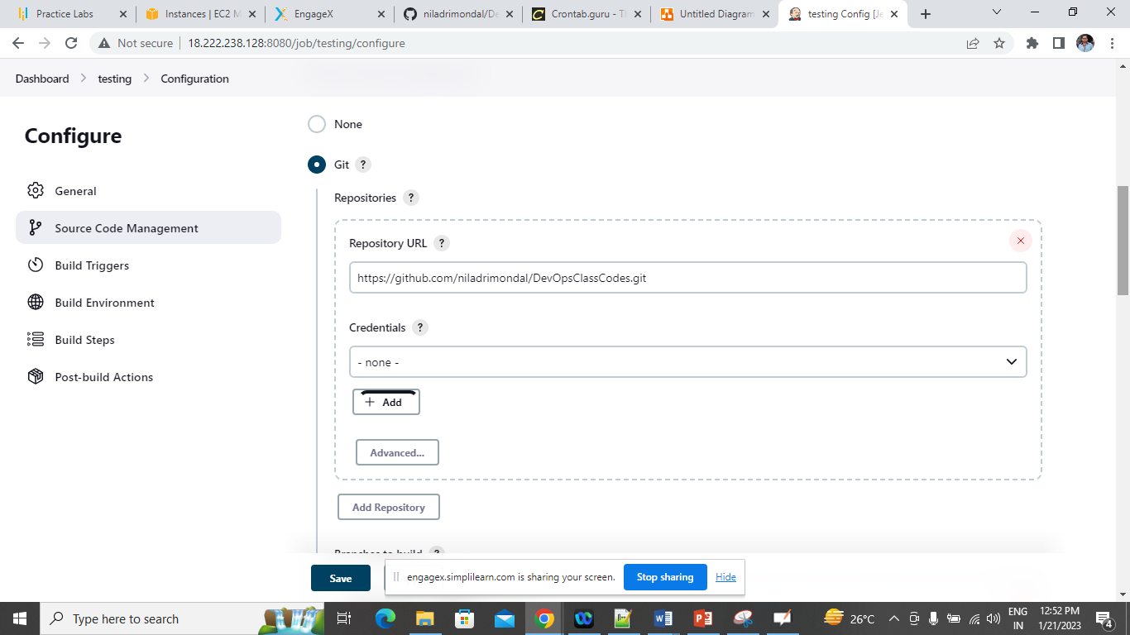

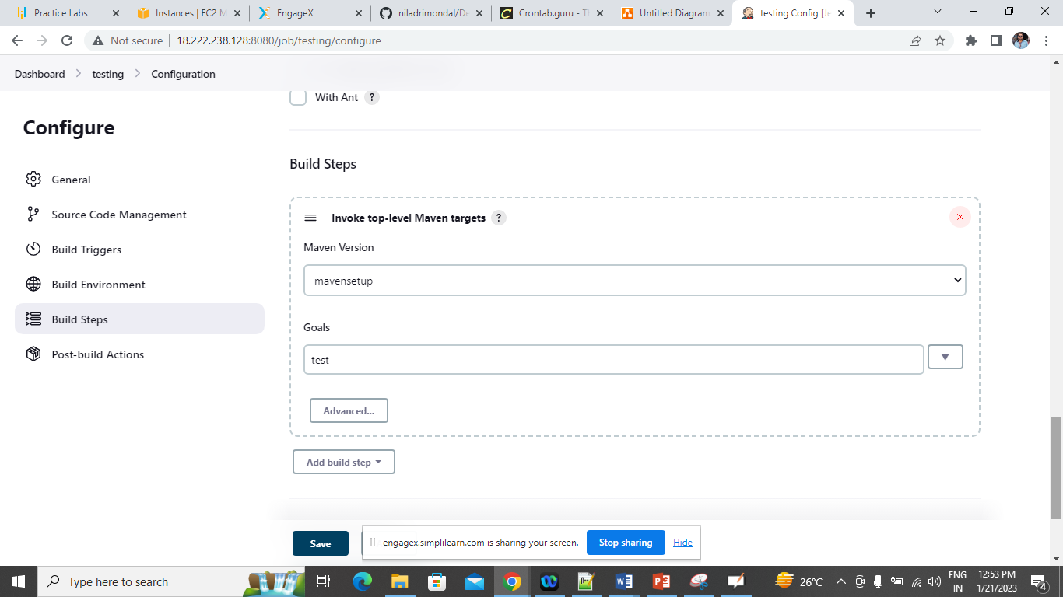

Quality Assurance

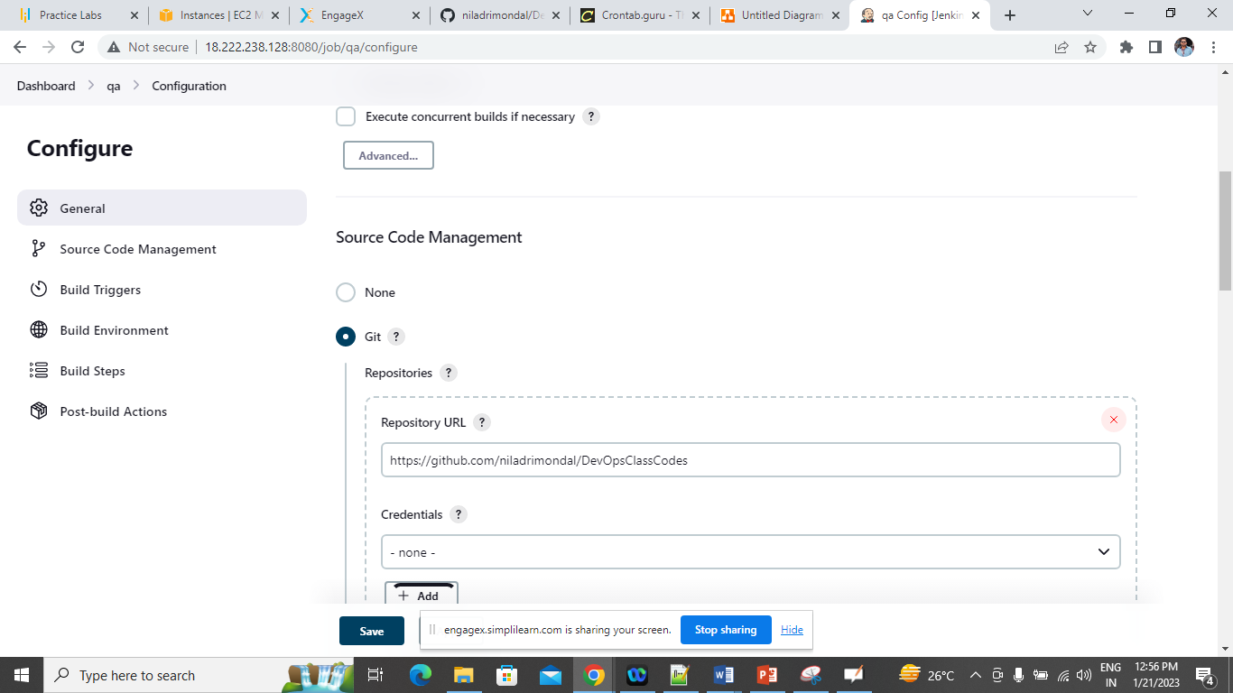

To get the Static Code quality result, you need to install this plugin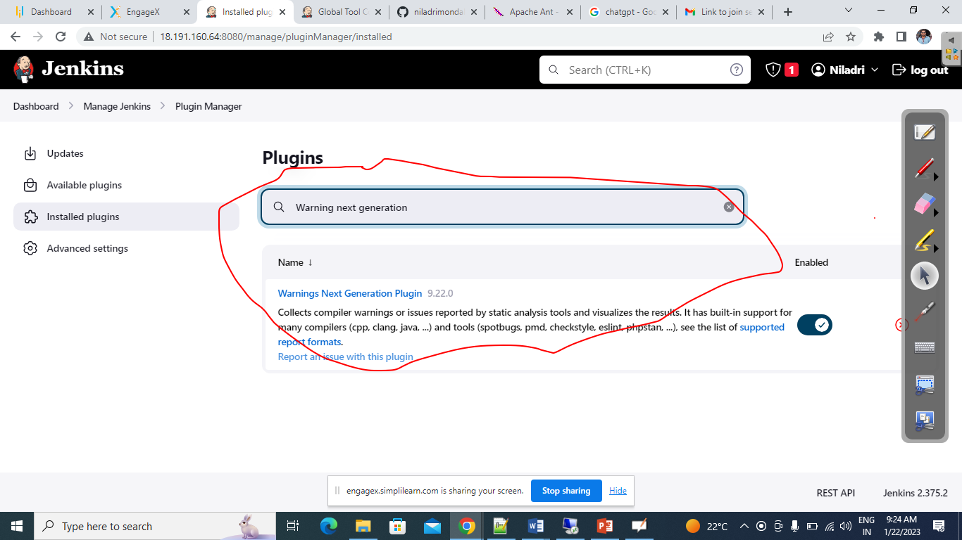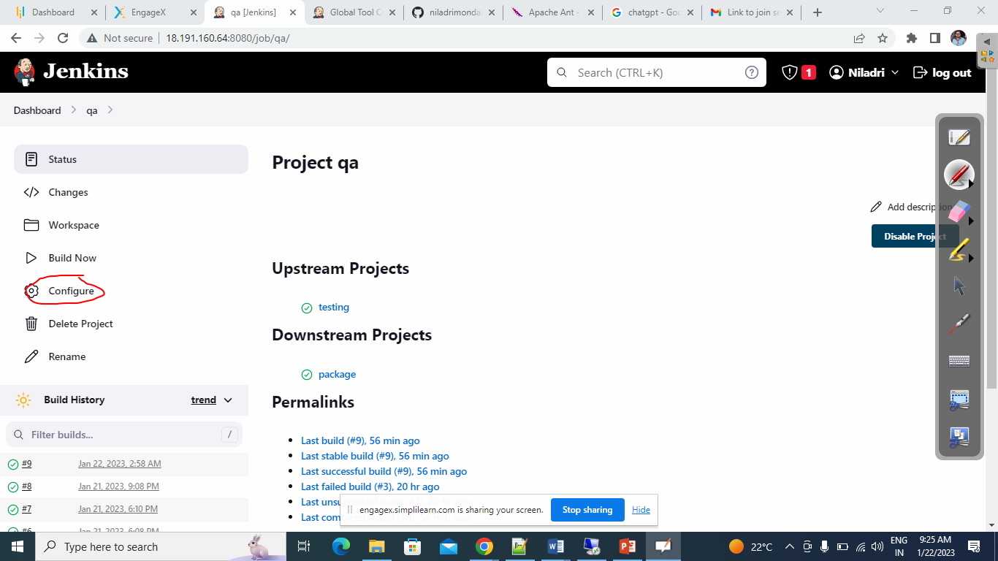

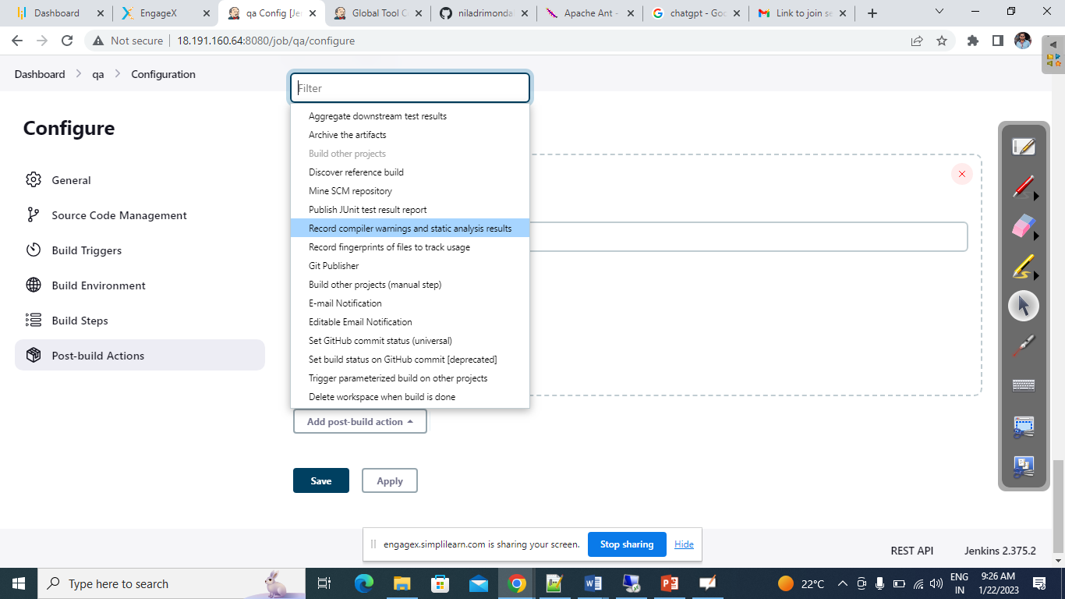

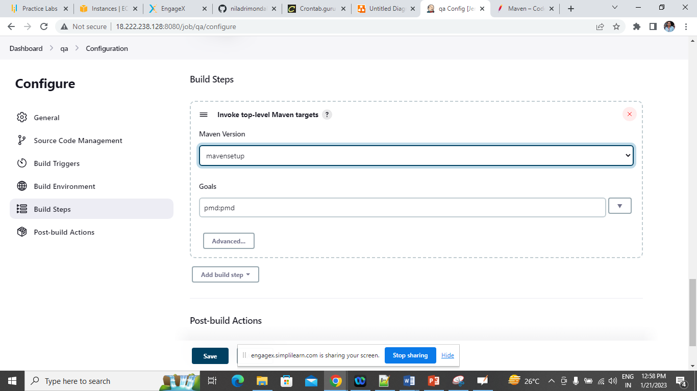

Package the code/Build the code

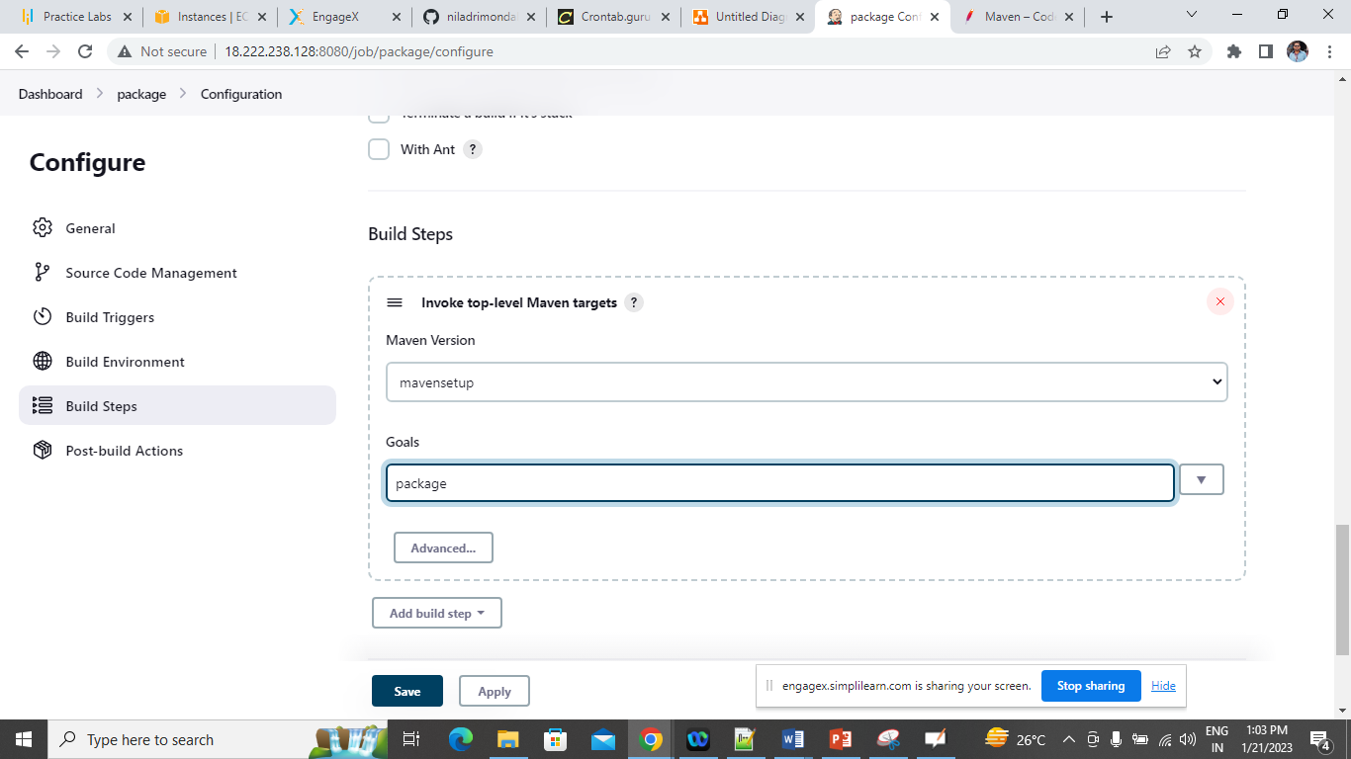

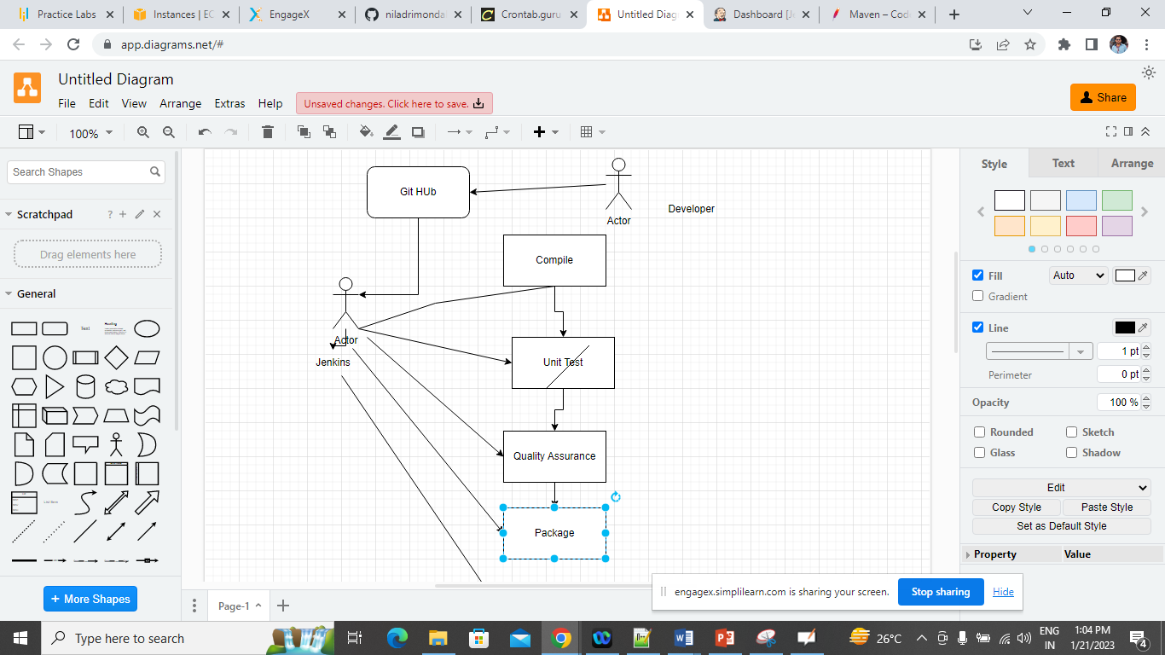

Now we are going to setup post build action

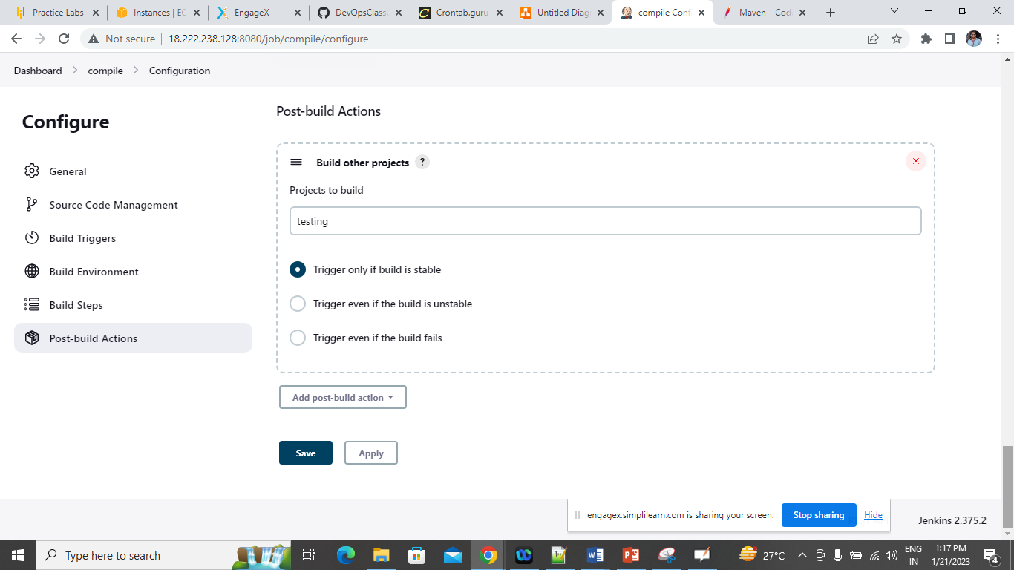

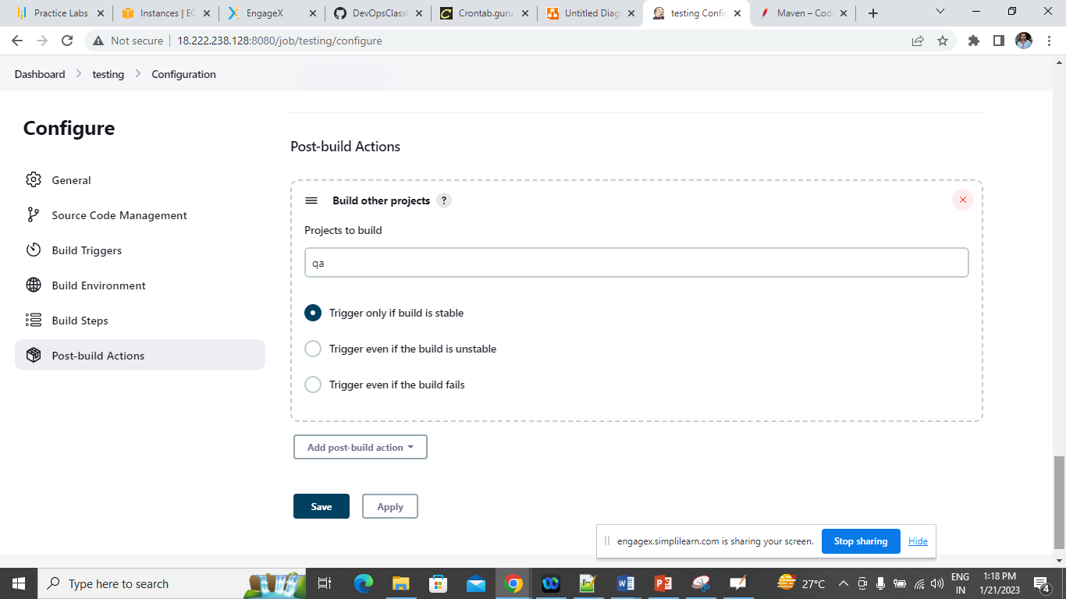

Plugin pipeline view should be installed.

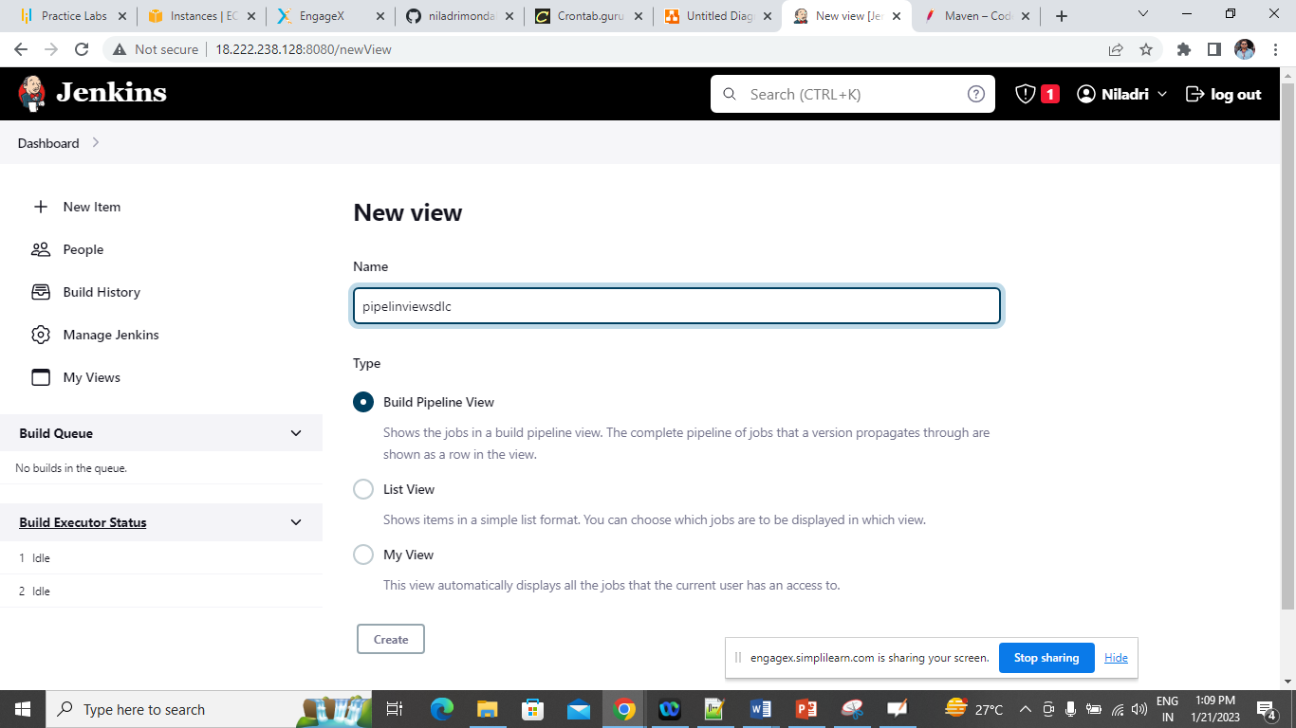

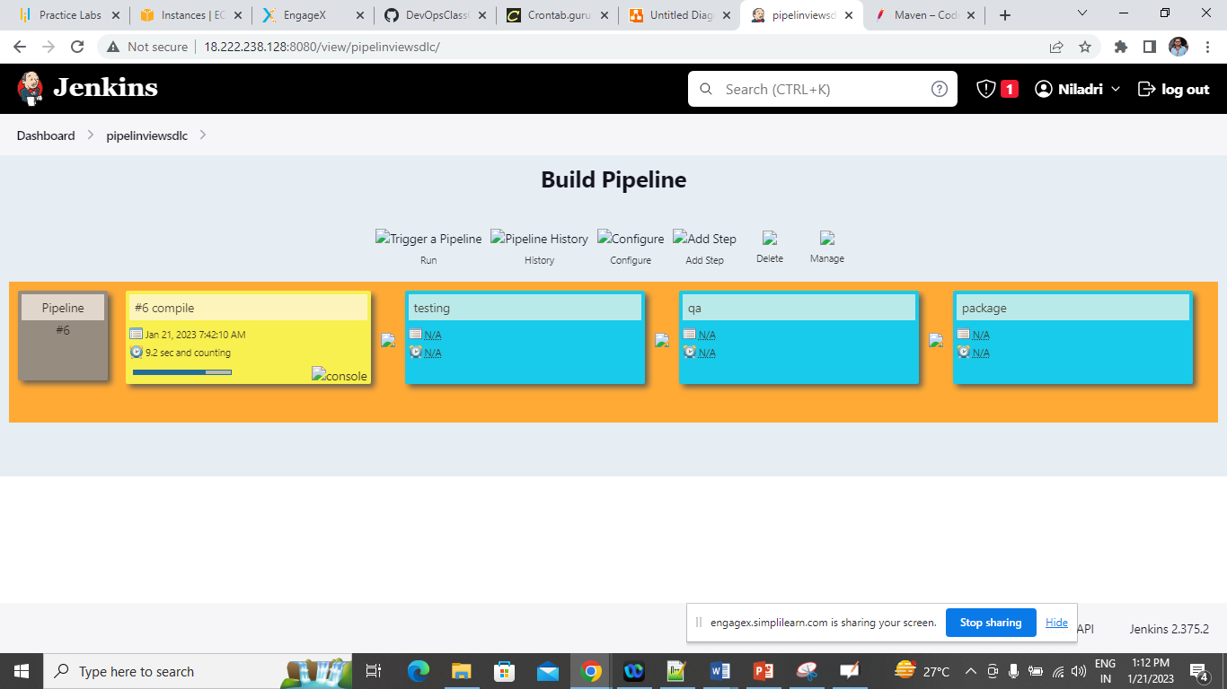

1. Download Apache Ant
2. Configure the same in ENV
3. Integrate sane in Jenkis

<https://ant.apache.org/bindownload.cgi>

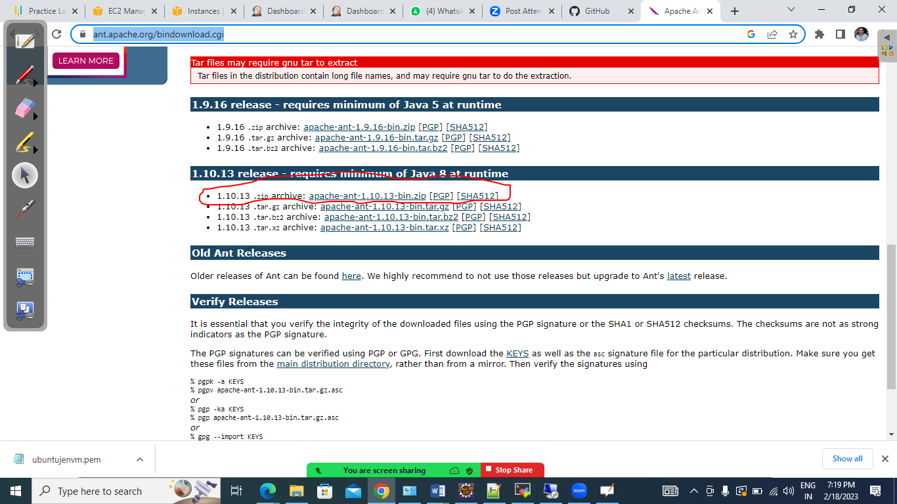

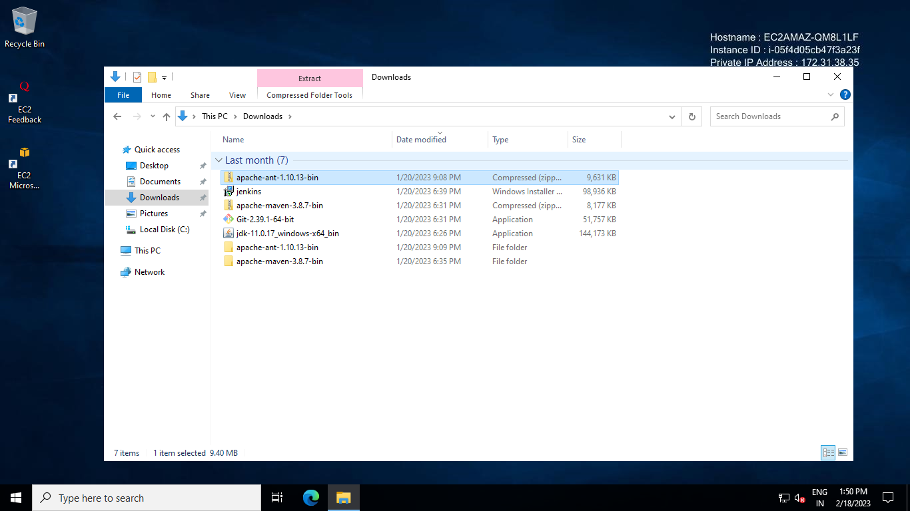

Now extract the zip file and copy the folder in somewhere and enable the env from there

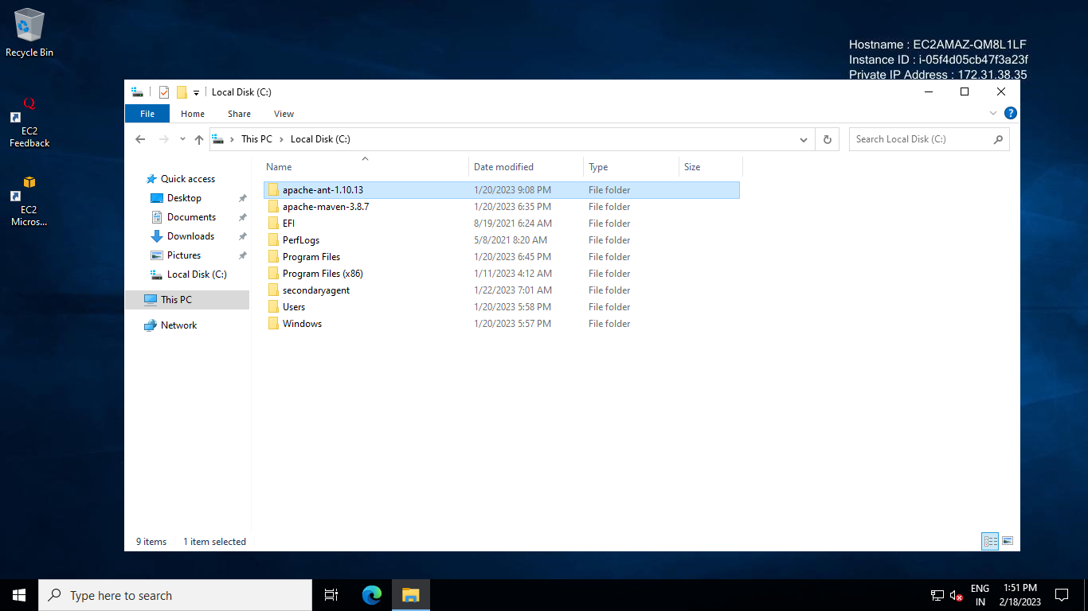

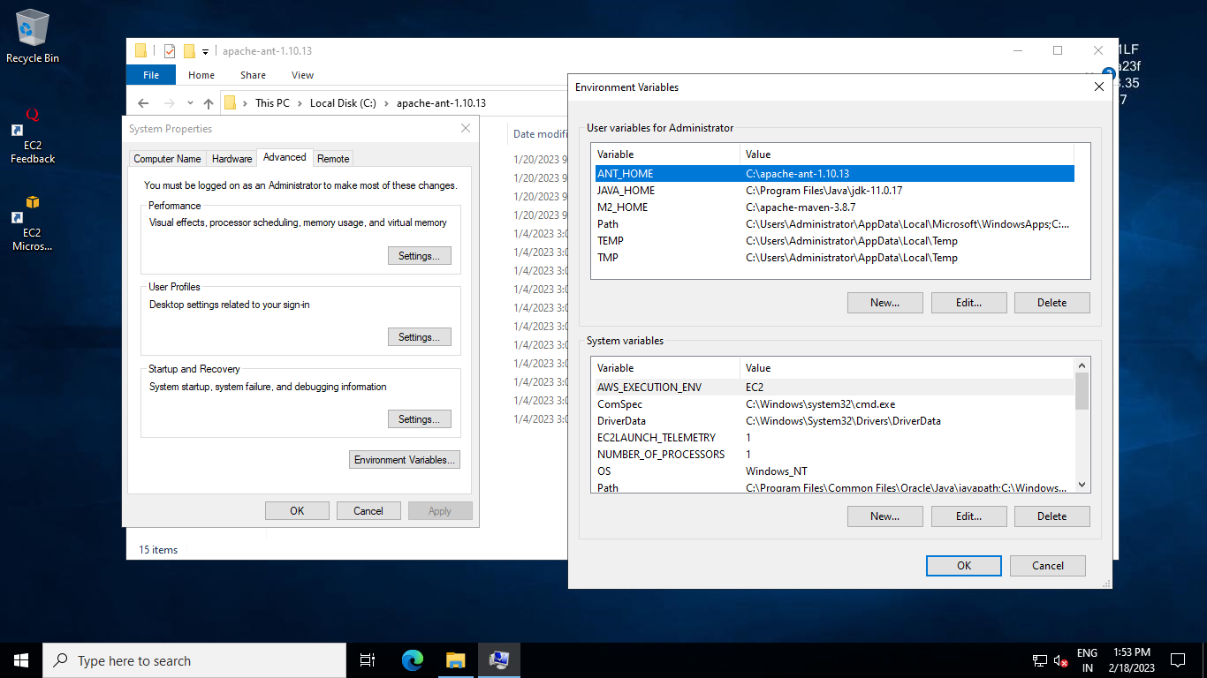

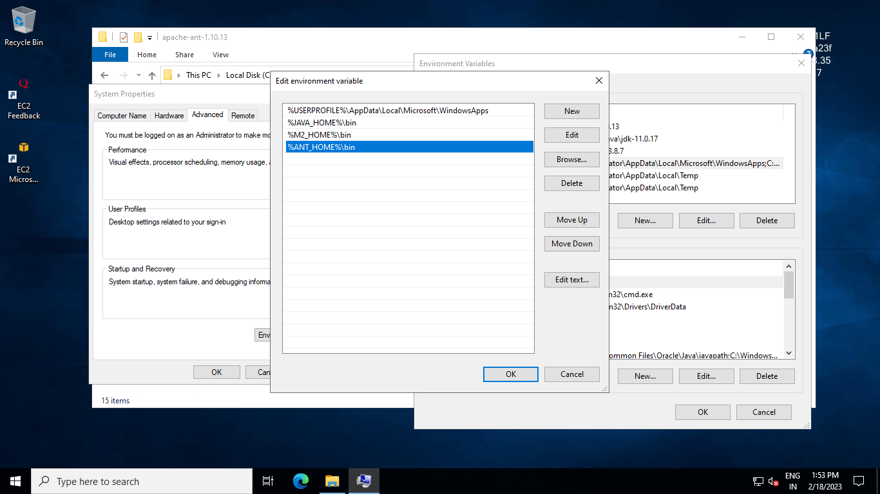

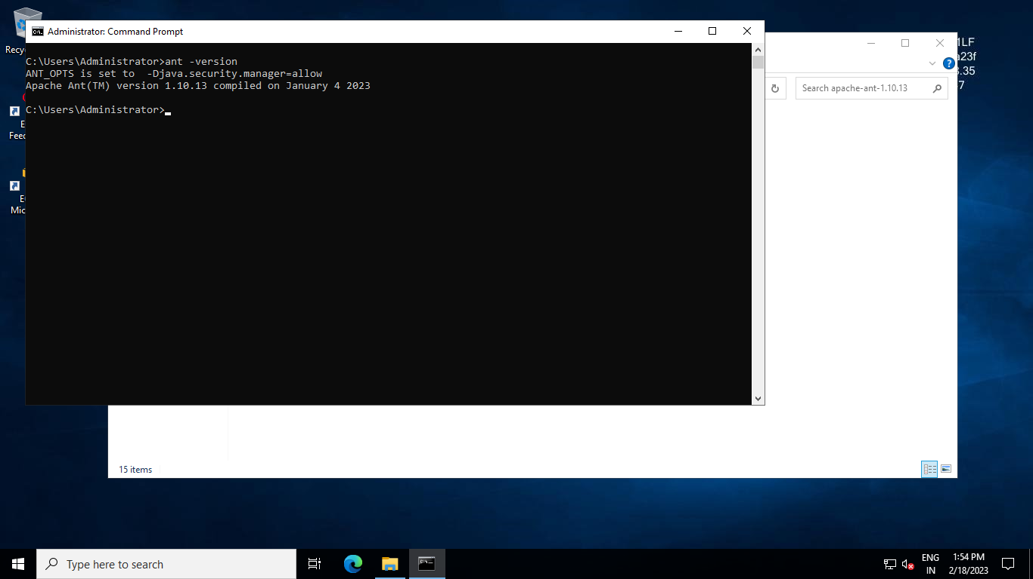

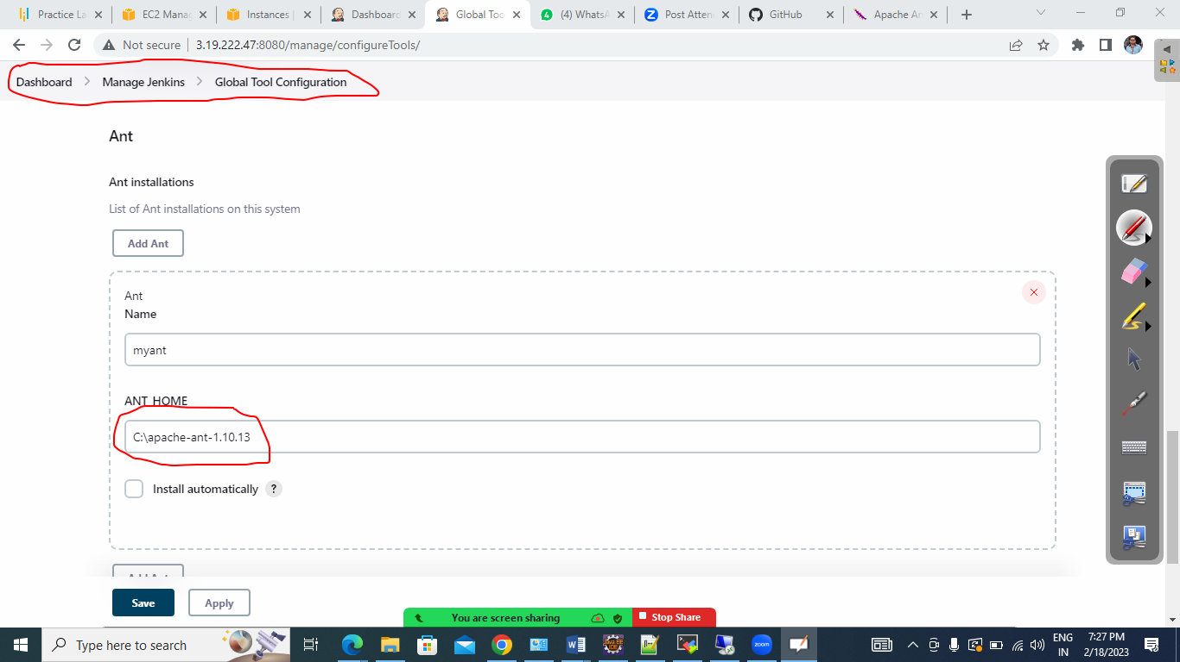

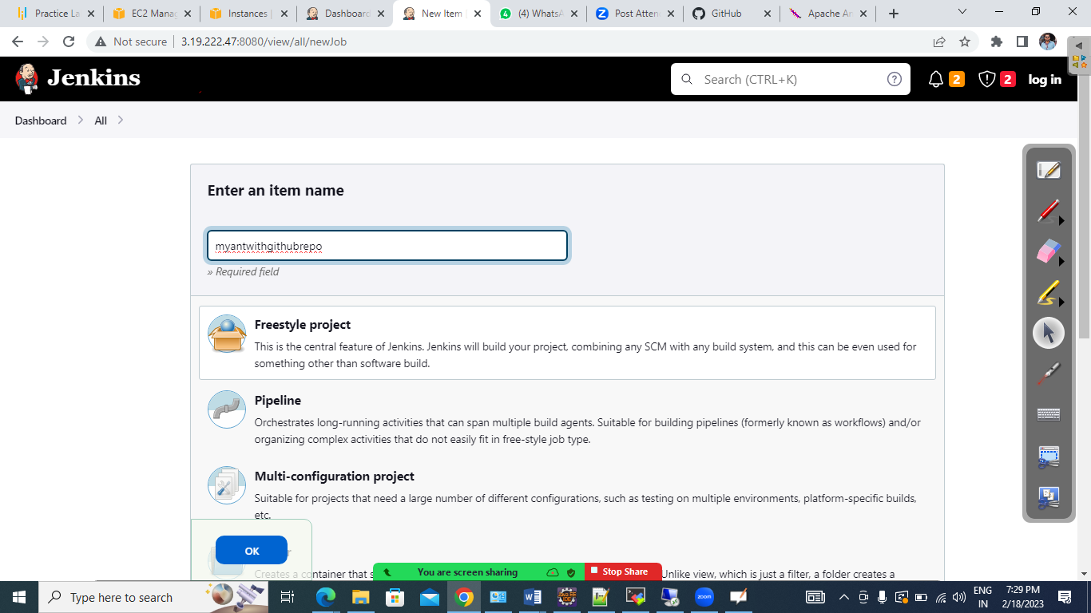

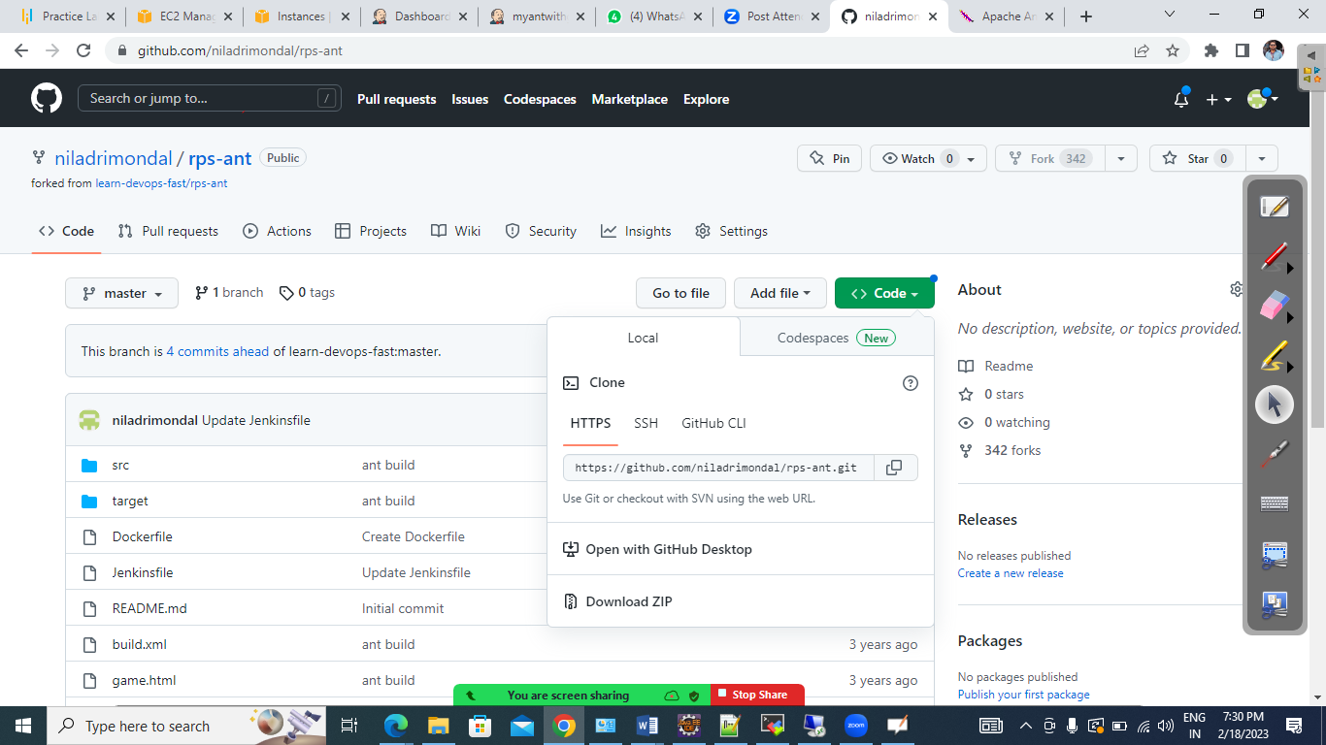

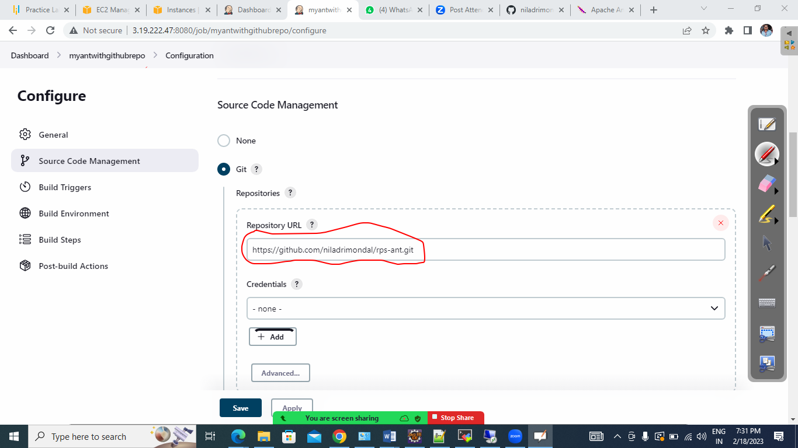

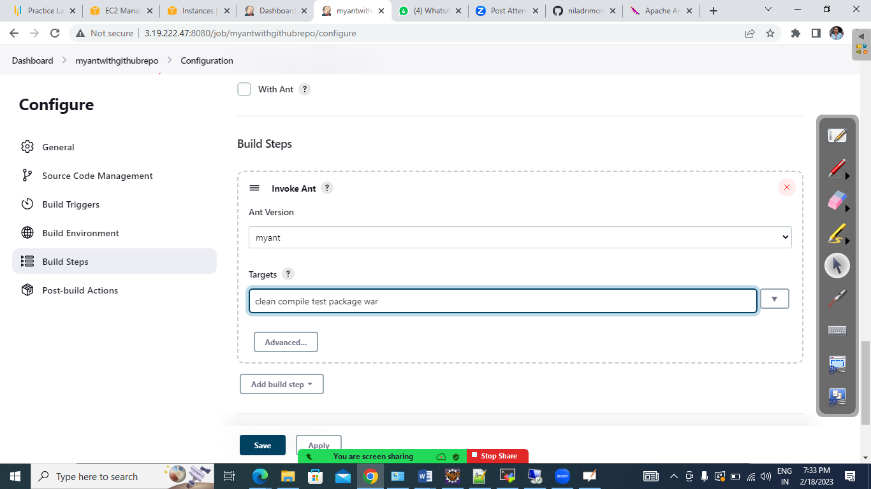

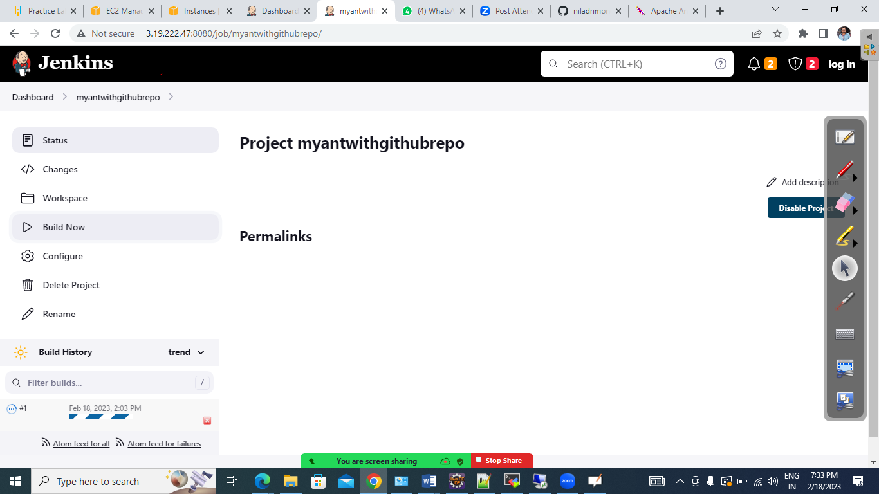

+++++++++++++++++++++++++++++++++++++++++++++++++++++++++++++++++++++++++++

Setup your FirstPipeline using some groovy script

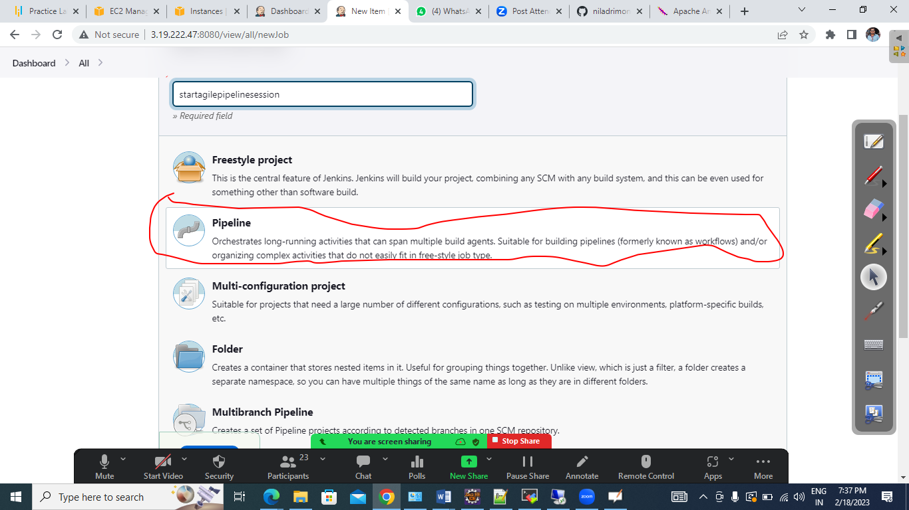

# Now we are going to use a Maven Github repo and build the same with Groovy script

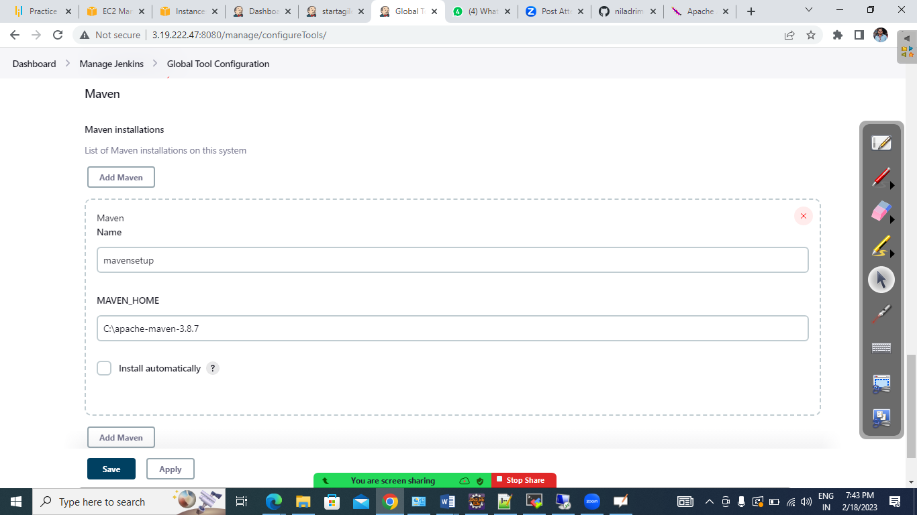

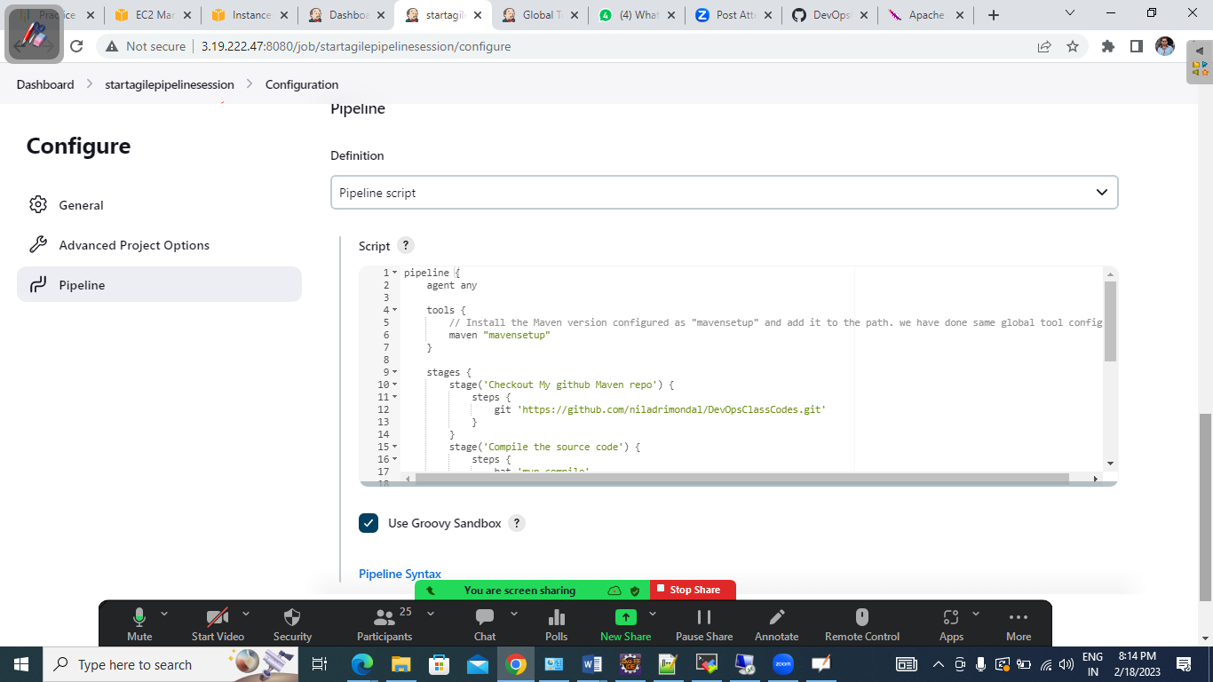

++++

pipeline {

agent any

tools {

// Install the Maven version configured as "mavensetup" and add it to the path. we have done same global tool configuration

maven "mavensetup"

}

stages {

stage('Checkout My github Maven repo') {

steps {

git 'https://github.com/niladrimondal/DevOpsClassCodes.git'

}

}

stage('Compile the source code') {

steps {

bat 'mvn compile'

}

}

stage('Run unit test case') {

steps {

bat 'mvn test'

}

}

stage('Run the Code quality check') {

steps {

bat 'mvn pmd:pmd'

}

}

stage('Package the code as a war file') {

steps {

bat 'mvn package'

}

}

}

}

++++

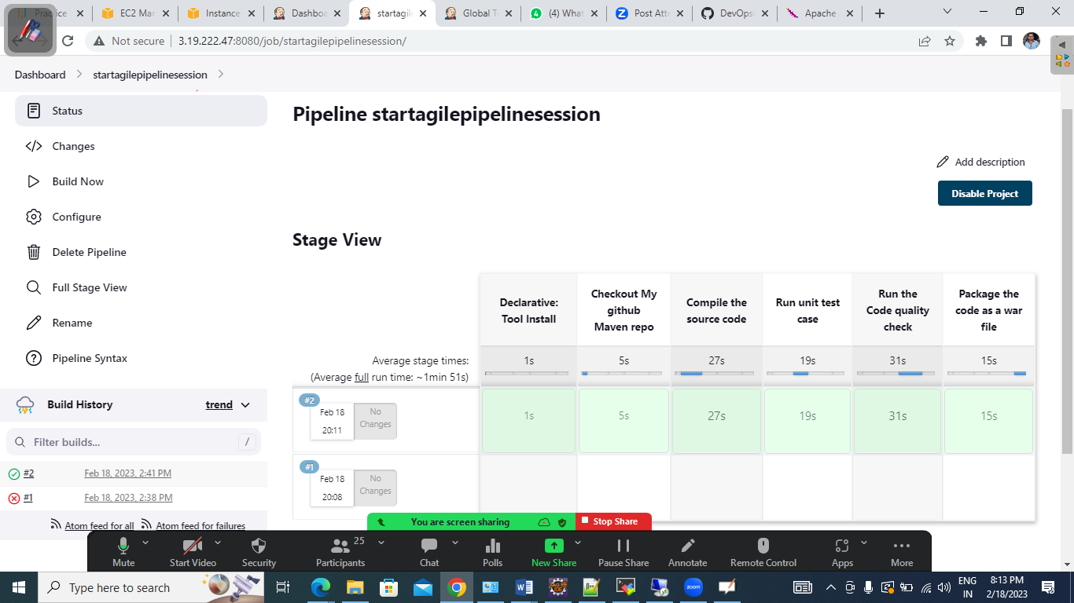

++++++++++++++++++++++++++++++++++++++++++++++++++++++++++++

We have install Jenkins in Ubuntu VM and also created another VM for secondary slave node

Created a directory inside the slave node and used the same for remote root directory

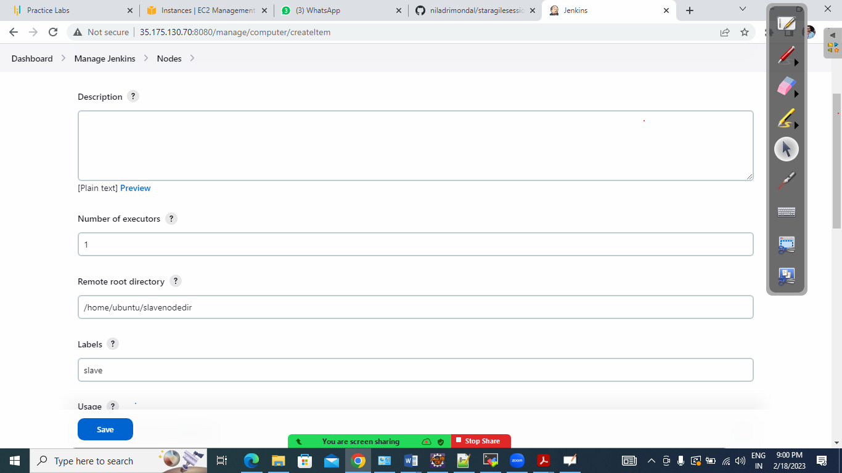

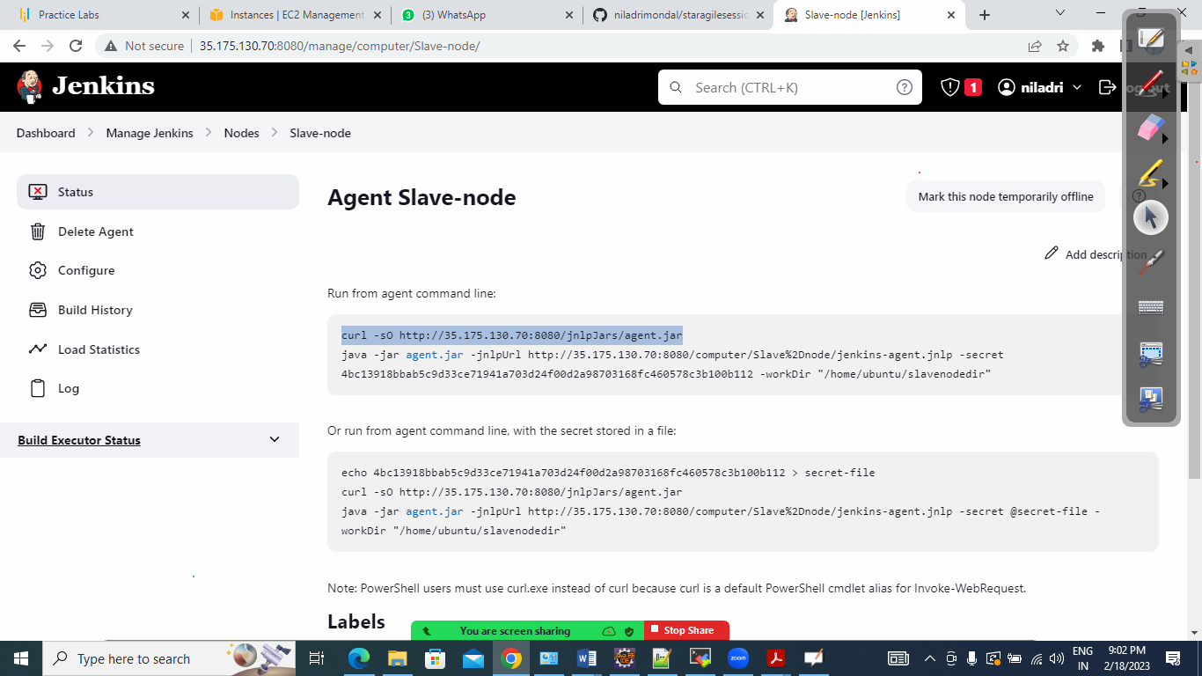

Run the commands in slave node

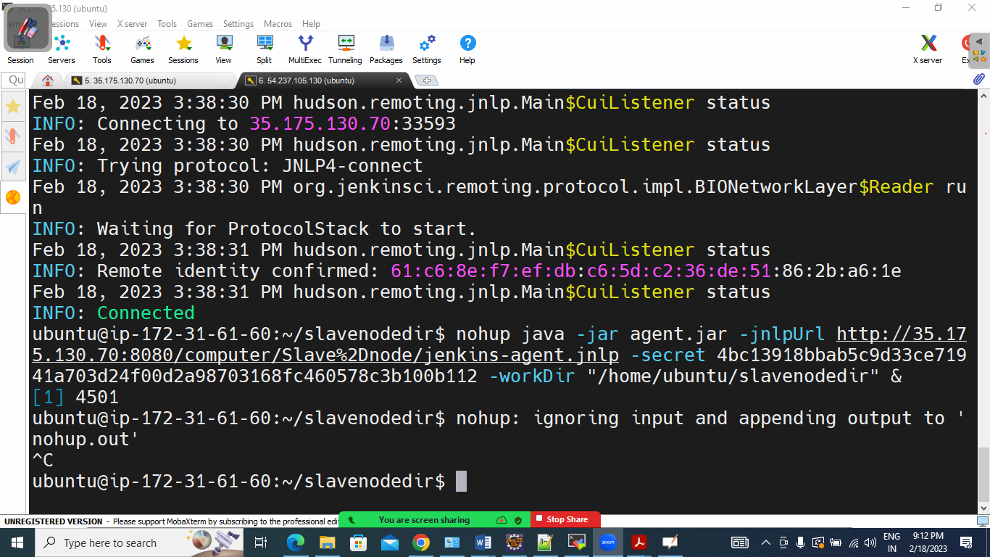

+++++++++++++++++++++++++++++++++++++++

Ubuntu Machine Jenkins Jobs:

